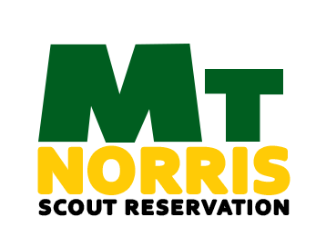
2017

GREEN MOUNTAIN COUNCIL
BOY SCOUTS OF AMERICA
838 US Rte. 2•PO Box 557•Waterbury, VT 05676
(802) 244-5189 • Fax (802) 244-5259
http://www.ScoutingVermont.org
info@ScoutingVermont.org

1/1/2017
“A WEEK OF CAMP LIFE IS WORTH SIX MONTHS OF THEORETICAL TEACHING IN THE MEETING ROOM.” –Lord Baden-Powell
LEADER’S GUIDE

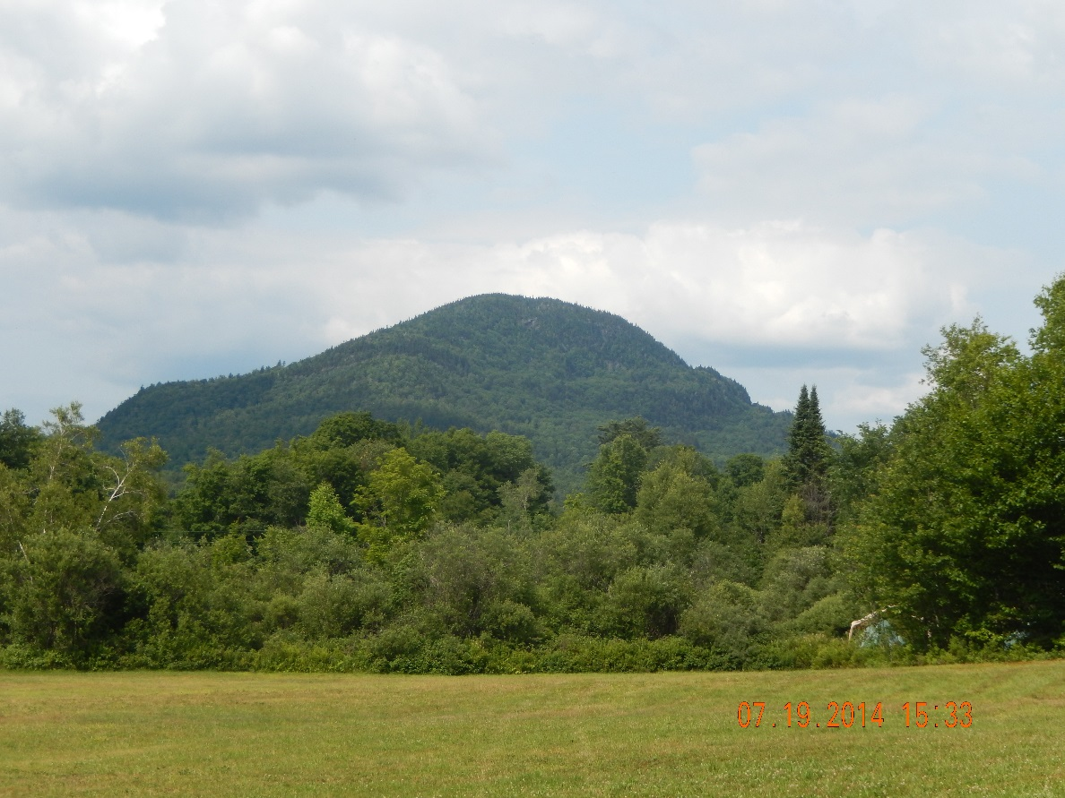
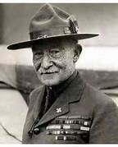
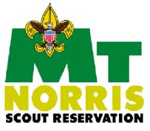

March 2017
Welcome home!

We want to thank you for your loyalty and support of being part of Mt Norris Scout Reservation! Whether your troop has been to camp in the past, or this is your first year attending, we are glad you have chosen our fine facility to experience a long-term summer camp for the Scouts in your troop.

Our Camp Ranger, Ajapeu Lodge Order of the Arrow, and our wonderful Mt Norris Scout Reservation Alumni Association have made some significant and noticeable improvements to the camp in recent years that took time and dedication to achieve. Many of you have participated in the process of rebuilding and redefining the great place this is. As we continue to improve the Camp Program we are also very interested in improving the Camp Facilities, so if you have a special skill or talent, materials that can be used this summer, or have some extra time to put into our Scout Reservation, please contact Kevin Macy, the Alumni Association President at mtnorrisalumni@gmail.com. We don't want to miss a chance to take your talent for granted. Too often we hear, "I wish I had known, I have that at home, or I can do that too bad I don't have my tools". We are not shy and promise to take advantage of any skill you offer.

Russ Baker is returning for his second year as Program Director and has been spending his retired time working full time to make the Mt Norris Program better than ever. He has developed some great expansions on the ideas he brought to life last summer with the off-camp adventures and new camp wide programs for all Scouts to participate We are fortunate to have Russ back with us and cannot wait until you get a chance to see and experience all he has worked on to improve the overall camp program.

With his work and that of the MNSRAA and many others in the Green Mountain Council, we are confidently offering a fifth week of camping that will include another series of the STEM/NOVA awards program, older boy programs, Trail to Eagle activities and merit badges, plus the "regular" camp activities of aquatics, shooting sports, Nature, Scout craft, and of course our premier First Class Adventure for the younger Scouts.

In addition the fifth week is a prime time to take advantage of the special pricing package for Jamboree participants and/or Scouts who attended Frontier Camp or are planning to attend National Youth Leadership Training (NYLT). Contact the Council Service Center for details on this special offer.

On behalf of the entire staff and the leadership of the Green Mountain Council we look forward to your stay with us and are committed to offering the best customer service and program support possible for you and your Scouts as you prepare to join us for a great summer camp experience at Mt Norris Scout Reservation! Hope to see you soon!

Yours in Scouting,

Mt Norris Summer Camp Staff

Table of Contents

GENERAL INFORMATION 2
In an emergency 4
CAMP FEES 7
CAMPSITES and SUPPLIES 9
CAMP CHECK-IN PROCESS 10
GENERAL POLICIES and PROCEDURES 12
MEDICAL INFORMATION 13
EMERGENCY PROCEDURES 17
YOUTH PROTECTION GUIDELINES 19
FRONTIER CAMP…………………………………………………………………………………………………………………………...21
CAMP PROGRAM 20
NATIONAL 2017 MERIT BADGE OFFERINGS 25
LEADER’S PRE-CAMP CHECKLIST 28
MNSRAA KITTED PROJECTS…………………….……………………………………………………………………………………..32
APPENDIX (additional forms and information) 34
Annual Health and Medical Record Parts A, B, and C………………………………………………………….…33
Routine Drug Administration Record……..………………………………………………………………………….….37
Tentaroo Instructions…………………………………………………………………………………………………………… 38
Scout [early] Release Request …….…………………………………………………………………………………….….39
Mt Norris Scout Reservation Alumni Association (MNSRAA) information………………………..……40
MNSRAA Membership Application……………………………………………………………………………..…………41
National Youth Leadership Training………………………………………… ……………………………………….…..42
Camp Map……………………………………………………………………………………………………………............…….44

GENERAL INFORMATION

CAMP PROPERTY

MT Norris Scout Reservation (MNSR) is owned and operated by the Green Mountain Council (GMC) of the Boy Scouts of America (BSA). Our scenic 1,000 plus acre property has been enjoyed by generations of Scouts and Scouters as a beautiful summer retreat for over 60 years. With shoreline access to Lake Eden, trails to the summit of Mt Norris, and our enthusiastic and qualified staff, we strive to offer exciting and unique camping opportunities to Scouts from around the world.

CAMP STAFF

MNSR does its best to hire the most qualified Scouts and adults available to serve on our camp staff. They are chosen for their knowledge of camp life, sense of Scouting’s values and are committed to help your unit succeed. Area directors hold a valid certificate of training from BSA’s National Camping School or equivalent skills.

CAMP RANGER

MNSR has a full-time year-round ranger, living on site who is in charge of all property maintenance, as well as overseeing programs at camp during the off season; for example, our very popular and often sold-out Winter Trek weekends. He holds a certification from the BSA National Camp School, Ranger Section.

CAMP ACCREDITATION

MNSR is licensed to operate by the State of Vermont, Agency of Human Services and receives formal authorization to operate from the Boy Scouts of America. The Vermont State Department of Health, the BSA's Regional Visitation Team, and the GMC's Camping and Properties Committees certify that the camp adheres to all current health and safety guidelines. As a result of the hard work of many helping hands, MNSR has consistently received BSA national camp accreditation.

PRE-CAMP LEADER'S MEETING

Camp representatives will visit each of the District Roundtables early in 2017. Watch the website and attend roundtables regularly to find out more and pick up the latest camp information. For out of council units, contact Camp Director Bill McDonald at billmacd04@yahoo.com, or the council service center in Waterbury, VT (802-244-5189) with questions or for additional information related to the camp program, registration, and operation. We are happy to make troop promotional visits, as well. The camp leadership is also preparing to set up “Go To Meeting” conference calls to help answer any questions leaders may have. Watch for an email with date and time.
DRIVING DIRECTIONS
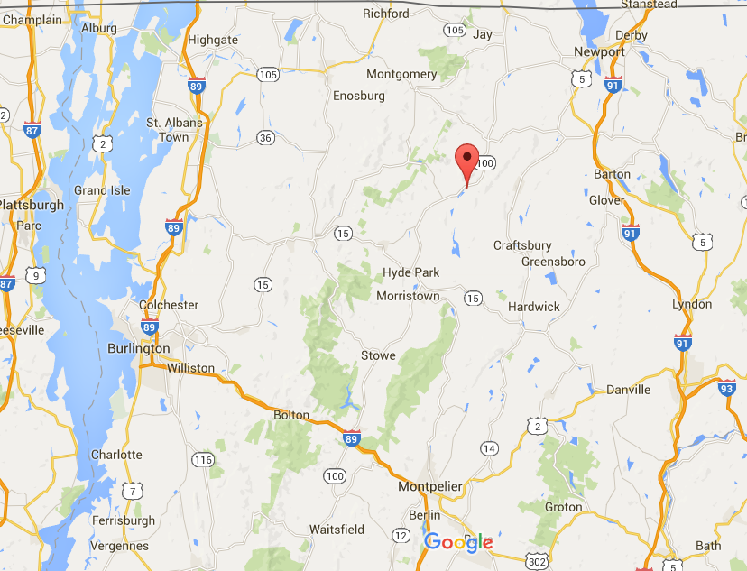

From Interstate 89, take the VT-100 exit, Exit 10 toward US-2/Waterbury/Stowe. Continue to VT-100 north to Morristown, about 20 miles. In Morristown enter the roundabout and take the 3rd exit onto VT-15/VT-100. Within two miles, enter another roundabout and take the 1st exit onto VT-100 heading north. In 12.6 miles the sign for MT Norris Scout Reservation is on your right and marks Boy Scout Camp Road. Turn right onto Boy Scout Camp Road and follow it to the large parking lot behind the dining hall. For safety, please drive 5 MPH once you have entered camp property.

To reduce in camp traffic:
After checking in, one equipment vehicle will be allowed to drive to the troop's designated campsite to unload gear and then return to the main parking lot. Depending on the size of your unit, two vehicles may be allowed. For additional arrangements, please contact the camp director prior to arriving at camp.

COMMUNICATIONS TO AND FROM CAMP

In an emergency parents should call the council service center 802-244-5189 between the hours of 9:00 AM and 5:00 PM, Monday through Friday

The camp’s office phone is its business line. Scouts, leaders and staff are discouraged from using it except for official business. If your business is urgent; the number is 802-635-7415, leave a message. Be sure to give this number to the parents of the Scouts.

AT&T is the only reliable cell phone service in camp.

Wi-Fi is available at the camp office and Scoutmasters’ lounge.

Outgoing mail should be left in the mailbox on the porch of the camp office. A staff member will take it to the post office when picking up the day’s incoming mail.

Incoming mail to Scouts and leaders is distributed to their units by the site guides when it arrives. Mail usually takes two to three days to reach the camp. Mail should be addressed to campers as follows:

Individual’s name
C/o Mount Norris Scout Reservation
Troop ###, _______________Campsite
242 Boy Scout Camp Road
Eden Mills, VT 05653

UNIFORMING

One of the METHODS by which Scouting achieves its AIMS is the uniform. We ask that Scouts and leaders wear their complete Boy Scout uniform for retreat (5:50 p.m. each day), at Vespers (Wednesday evening, 7:00 p.m.) and at the opening and closing campfires.

Appropriate activity uniforms (a Scout t-shirt with Scout shorts or pants) should be worn to breakfast and during the day’s activities. Shirts and closed-toe shoes are always required. Open-toed shoes are only permitted in the shower house, at the waterfront and in your tent (travel to and from these exceptions require closed-toed shoes or sneakers).

TRADING POST

It’s difficult to say how much money a Scout should bring to camp to spend at the trading post. The amount they’ll spend depends on what merit badge books and materials they’ll need and how much they are likely to spend on snacks and souvenirs.

In general, merit badge books cost $5.00 and handicraft kits are about $7 to $10. Camp T-shirts are around $15.00. We suggest $30-$50 as a reasonable amount, and request it is in smaller bills; tens, fives, and ones, to facilitate making change.

A reminder that trading post accounts CANNOT be set up for troops or Scouts. The trading post does accept VISA, MasterCard and Discover credit cards.

DINING

Scouts and leaders will enjoy tasty meals in the Flynn Lodge dining hall. Experienced cooks will prepare your meals. Breakfast and dinner will be family-style dining, while lunches will be served cafeteria style. At lunch, you are encouraged to sit anywhere you would like and to share a table with Scouts and leaders from other troops. At breakfast and dinner, each unit will have assigned tables and should reserve a place for at least one staff member at each table. Units must designate waiters and send them to the dining hall at least 15 minutes before breakfast and dinner to set the tables. The dining hall steward will supervise the waiters in setting tables, serving food and clearing and cleaning tables. Units are responsible for the cleanliness of their table(s) and surrounding area. A Scout is helpful—you don't have to be a waiter to help clean up after a meal!

Flag ceremonies will be held before breakfast and dinner.

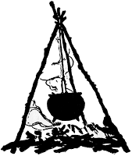
Thursday's dinner and Friday’s breakfast will be prepared by your unit in your campsite. MNSR staff will provide the ingredients and recipes for Dutch oven cooking. Units should bring appropriate utensils to camp. Dutch ovens are available from the quartermaster. Food pick-up for Thursday's dinner is at 4:00 p.m. and Friday’s breakfast pick-up is 6:30 a.m. Should you need assistance, please do not hesitate to contact the camp commissioner. Our staff stands “ready, willing and able” to ensure your troop has great campsite meals. If you would like to prepare more meals in-site, please contact the camp director prior to arriving at camp so that we may accommodate your needs.

SOLO SCOUTS: PROVISIONAL CAMPING

At MNSR we firmly believe that all boys who want to attend camp should be able to, no matter what week their troop is coming. Scouts are welcome to attend MT Norris as patrols, groups of friends, or on their own. Solo “Troops,” or groups with 10 or more Scouts will stay in their own campsites with a camp assigned Scoutmaster aged 21+ years and an assistant Scoutmaster aged 18+ years. Smaller groups or individual solo Scouts will be placed with a cooperating troop in that unit's campsite. Solo Scouts have the same opportunities as any other Scout in camp during the week.

VENTURING

Venture crews are welcome at MT Norris for all weeks, including STEM (science, technology, engineering, and mathematics) week. Venturers who earned First Class rank as registered Boy Scouts are qualified until their 18th birthday to continue with Boy Scout advancement and are eligible to earn any of the offered merit badges.
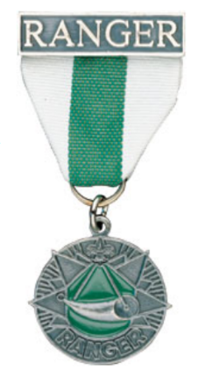
We will also be offering some of the activity requirements for the Ranger Award. Program areas in camp will make every effort to incorporate Venturing awards requirements alongside the standard merit badges. We will be offering Cooking, Emergency Preparedness, Land Navigation, Wilderness Survival, Ecology, and First Aid merit badges.

Coed Venturing crews are required to have at least one male and one female advisor, each of whom must be at least 21 years of age. Venturers must have a same-gender buddy. Provisional Venturers must also have a buddy of the same-gender.

CAMP FEES

2016 SUMMER CAMP FEE SCHEDULE

The fees for summer camp at MNSR are set by the Green Mountain Council Camping Committee and approved by the Council Executive Board. As always, every effort is made to keep fees as low as possible and still provide a well-rounded summer camp experience for each Scout who attends. As a testament to this, the GMC camps are among the best-priced in the Northeast Region for our families.

The following fee structure has been adopted by the GMC to make paying for summer camp easier on the units and easier to keep track of upon your check-in at camp. All fees are on a per week basis.

MT Norris Boy Scout Resident Camp/Specialty week

Unit Week Reservation $100 non-refundable and will be credited to unit’s final bill
Special Early Bird Rate $335 per Scout ($100 deposit due by January 31, 2017)
Early Bird Fee $360 per Scout ($100 deposit due by May 1, 2017)
Regular Fee $395 per Scout after May 1, 2017
Adult Fee $75 per adult (subject to $20 late fee)
Adult Day Fee $25 per adult per day

Summer Camp Payment Schedule and Fees 2017
Special Early Bird deposit by January 31, 2017
- Early Bird deposit by May 1
- By June 1 – All fees due
- Any payments for youth or adults made after June 8, 2017 will be charged an additional $20 per person

If a Scout attends National Youth Leadership Training (NYLT) or attends a second week of camp, their fee is reduced by $35. If a family has two or more Scouts attending camp, the fee is $300 per Scout. However, to take advantage of these reduced fees, payment must meet the early bird registration date.

Out of council units must have proof of accident and sickness insurance. Units can get this information from their local council service center. If your council does not provide this, it can be purchased for $5.00 per person from the Green Mountain Council Service Center. Green Mountain Council units already have this insurance.

If a unit or Scout cancels after May 1st, the unit forfeits $100 per boy, plus the site reservation fee. No fees will be refunded after June 1st except in extreme cases (i.e. death, hospitalization – having to attend summer school is not an extreme case). Please remember this money has already been invested by June.

Deposits and paid fees are non-refundable but can be transferred to another NEW Scout not already on a unit’s roster. Fees CANNOT be combined and credited to another Scout who is already signed up to attend camp.

Newly recruited and registered Scouts (Cub, Boy or Venturer) or Webelos, who have crossed over to troops and register in the unit during 2017, pay the early bird fee.

Financial Assistance forms are due by April 12, 2017 in the council service center. The campership committee is scheduled to meet immediately following this deadline. Please make sure the forms have been submitted to the council service center and not just “postmarked” by the due date. The committee cannot be responsible for forms lost or delayed in the mail.

FOR THE LATEST INFORMATION GO TO:

http://www.scoutingvermont.org/camping

CAMPSITES and SUPPLIES

Mt. Norris is very well equipped with campsite equipment. Each site has a rake, shovel, hose, broom, and scrub brush as well as a 7’-6” x 9’-6” wall tent with cots for every two Scouts. The Belvidere and Stratton campsites have lean-tos with bunks for up to four Scouts. Additional equipment or supplies may be requested for use through the Camp commissioner or camp director and can be picked up at the quartermaster's shed behind the dining hall. Most sites have 3” mattresses, but come prepared with your own sleeping pad or air mattress for additional comfort.

Campsite tents and equipment are a major expense in the operation of summer camp and we strive to maintain and upgrade as funds allow. Campsite equipment will be inspected and logged upon your arrival in camp and again before you check out on Saturday. While we do not anticipate any problems, if necessary, your unit will be held responsible for the replacement cost of damaged equipment on a case-by-case basis.

CAMPSITE RESERVATIONS

A unit may reserve it’s week at camp with a $100.00 deposit (please refer to the Camp Fees section). This deposit is non-refundable but may be applied toward summer camp fees. To ensure your unit receives the campsite of choice, a Site Reservation Form (see http://www.scoutingvermont.org) must be filled out and returned to the council service center as soon as possible.

Please remember that each campsite may have to be shared by one or more troops. Should this occur, we will contact units sharing sites to coordinate arrival times and any other necessary arrangements.

CAMPSITE | ACCOMMODATIONS | CAPACITY*
Mt. Mansfield | Tents on outriggers and a cook-shack | 32
Jay Peak | Tents (4 on outriggers) | 18
Mt. Ellen | Tents on outriggers and a cook-shack | 24
Equinox | Tents on outriggers and a cook-shack | 20
Sugarbush | Tents on outriggers | 16
Bromley | Tents on outriggers | 24
Ascutney | Tents on outriggers | 24
Belvidere | Adirondack Lean-to’s | 32
Stratton | Adirondack Lean-to’s | 32
*Campsite capacities will be strictly adhered to.
*If your unit requires more space, an adjoining site should be reserved. Units may also bring personal tents for both leaders and Scouts.
*If your unit cannot meet minimum site capacity, you may be asked to share the site.

CAMP CHECK-IN PROCESS

(See attached Check-In Form)

Check-in at camp occurs on Sunday afternoon and can last a couple of hours. To help move the process along, we recommend that the Scouts are already dressed in their swim trunks. Every camper will need to do a swim test on Sunday if they plan to use the waterfront. Due to the nature of the lake environment, the camp does not accept pre-tests.

To make this process as smooth as possible, we have developed the following procedure.

- Units arrive at MNSR by 1:00 p.m. Please make every effort to arrive as a troop. If you need to arrive earlier than 1:00 p.m., please contact us in advance to make arrangements.

- Vehicles will be parked in the parking lot by the dining hall. Scouts and their leaders will report to the camp office to hand in their camp roster, review the troop's account, and verify Scout attendance. Please do not line up along the road parallel to the office,

- Medical checks will also be performed at the camp office. All Scouts and leaders must have a current and complete Annual Health and Medical Record. A copy of the form has been included in the appendix of this Leader's Guide. You can also download, fill out, and print your own copy by following this link: http://www.scouting.org/filestore/healthsafety/pdf/680-001_abc.pdf.
- All persons taking any prescription medication must fill out the appropriate number of Routine Drug Administration forms (found in the Appendix – print clearly), prior to check-in so that they may be reviewed by the Health Officer. This will significantly expedite the check-in process! Please bring all necessary medical paperwork AND MEDICATIONS in an original pharmacy container to the camp office to be reviewed by the health officer.

- Once this process has been completed, units will be assigned a site guide. The site guide will accompany the unit to their campsite, assist in settling in, and conduct the camp tour. The tour includes the mandatory swim check.

- After the tour, Scouts and leaders are invited to settle in and relax at their campsites until 5:30 p.m. at which time an emergency alarm drill will be conducted, and everyone in camp will report to the parade field.

- After emergency procedures are reviewed, a flag ceremony will be performed, and then Scouts and staff will enter the dining hall for dinner.

- There will be a round table (meeting) of adult leaders and senior patrol leaders (SPLs) following dinner to meet with key camp staff members and review details for the upcoming week.

Opening campfire is at 8:00 p.m. Taps and lights-out at 10:00 p.m. Get lots of rest for Monday!

GENERAL POLICIES and PROCEDURES

TRANSPORTATION

Transportation to and from camp is the responsibility of the unit. We suggest drivers be selected well ahead of departure. Cars should not be overloaded and must be adequately insured. The Boy Scouts of America requires the following conditions be met in transporting Scouts:

- All vehicles must be covered by automobile liability insurance with limits that meet or exceed requirements of the state in which the vehicle is licensed. It is recommended that coverage limits are at least $50,000/$100,000/$50,000. Any vehicle designed to carry 10 or more passengers is required to have limits of $100,000/$500,000/$100,000.
- All passengers must have and wear an individual seat belt
- No one is permitted to ride in the beds of pick-up trucks
- All drivers must be over the age of 18, mature, capable, and insured to the standards above.

You must carry at least Vermont state minimums on your auto insurance policy; which are $25,000/$50,000/$10,000.

VEHICLES in CAMP

All vehicles must be parked in the dining hall parking lot for the week. For safety reasons, and in accordance with National BSA guidelines, only camp vehicles may be operated on camp roads. You may drive one equipment vehicle to your camp site to drop off equipment. Immediately after dropping equipment and/or a unit trailer, the vehicle must be returned to the parking lot. Speed limit in camp is SLOW! Please keep all vehicles operating on camp property below 5 MPH.

FIREARMS, AMMUNITION, and ARCHERY EQUIPMENT
Ample equipment is available for all shooting sports programs offered as part of the camp program. Scouts and leaders may not bring private firearms, ammunition, nor archery equipment from home for use at summer camp. These will be confiscated and stored until your unit leaves camp on Saturday.

CAMP HEALTH OFFICER
All first aid emergencies must be reported to the camp health officer immediately. Our health officer is specially trained in First Aid and OSHA Blood-borne Pathogens procedures and has developed a plan to work with the local agencies that provide emergency services to the camp. In an emergency, the camp health officer working with the camp director will assume responsibility for the scene and will be the person in charge of the emergency scene until the arrival of outside emergency medical services.

MEDICAL INFORMATION

PHYSICAL EXAMINATIONS and ANNUAL HEALTH AND MEDICAL RECORD

The Scouting adventure, camping trips, high-adventure excursions, and having fun are important to everyone in Scouting---and so is your safety and well-being. Completing the Annual Health and Medical Record is the first step in making sure you have a great Scouting experience.

The Boy Scouts of America requires that everyone who participates in a Scouting event have an annual medical evaluation by a certified and licensed health-care provider – a physician (MD or DO,) nurse practitioner, or physician assistant.
Following in-processing the camp health officer will keep a copy of the health and medical records locked in the health lodge. One step in your unit’s out-processing is to retrieve these records. Camp staff and unit leaders must make every effort to always protect the privacy of unit participants by protecting their medical information.

Anyone staying at MNSR longer than 72 consecutive hours must bring a completed Annual Health and Medical Record (form 680-001) to in-processing.

Please note that this record is available as a fillable PDF, and members are requested to fill it out on their computer, then print the record (rather than printing the record and filling it out by hand). Doing this will improve the readability and accuracy of each member’s medical information and speed up in-processing. You can find a copy of this form in the appendix of this Leader's Guide or online at:

http://www.scouting.org/scoutsource/HealthandSafety/ahmr.aspx

Parts A and B are to be completed at least annually by participants in all Scouting events. This health history, parental/guardian informed consent and release agreement, and talent release statement are to be completed by the participant and parents/guardians. (We will accept immunization records as attachments)

Part C is the physical exam that is required for participants in any event that exceeds 72 consecutive hours, for all high-adventure base participants, or when the activity is strenuous and demanding. Service projects or work weekends may fit this description. Part C is to be completed and signed by a certified and licensed health-care provider – physician (MD-DO), nurse practitioner, or physician assistant. It is important to note that the height/weight limits must be strictly adhered to when the event will take the unit more than 30 minutes away from an emergency vehicle, accessible roadway, or when the program requires it, such as backpacking trips, high-adventure activities and conservation projects in remote areas.

DRUGS, MEDICATIONS, and ROUTINE DRUG ADMINISTRATION RECORD

The camp health officer must review all medications during check-in. Prescribed, self-administered medications for severe allergies, heart conditions, etc. must be reported to the camp health officer. Any medicine needed in an emergency may be carried by the Scout or leader (i.e. inhalers, epi pens). All other medicine will be locked in the health lodge and dispensed by the camp health officer.

Please advise us in writing a few weeks in advance of camp if you have any unusual medical requirements. Do not think your child will be fine without medicine for a week: make sure they have an adequate supply to last Sunday – Saturday. You SHOULD NOT STOP taking any maintenance medication unless instructed to do so by your doctor. As a reminder, Scouts taking any prescription medication will be interviewed by a qualified camp staff member upon arrival.
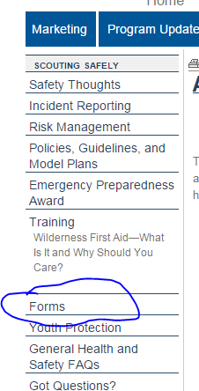
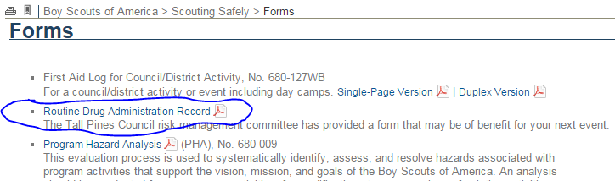
To facilitate the check-in process, parents need to fill out the appropriate Routine Drug Administration Record for their children. The camp health officer will review and sign this form after completing an interview with the camper. Care in filling this form out will help move in-processing along. A blank copy is in the appendix. Better yet, a PDF fillable version is online. Go to http://www.scouting.org/scoutsource/HealthandSafety/ahmr.aspx and click Forms and then click on Routine Drug Administration Record.

SCOUT EARLY RELEASE PROCEDURE

To ensure boys leave camp with an approved guardian any Scout leaving camp early must have a signed Scout Release Request. This form must be completed and signed by the unit leader, parent, and camp administration. We recommend all units stay in camp until Saturday morning to receive the full benefits of their week at camp. This and all other necessary forms can be found on the council website at http://soutingvermont.org and click on camping and then Mt. Norris summer camp.

ALCOHOL, DRUGS and TOBACCO

Alcohol and illegal drugs are not permitted in camp. Any adults found in possession or under the influence of alcohol or illegal drugs will be escorted out of camp. According to Youth Protection Guidelines, such instances will be reported to the scout executive for appropriate action. Any minor found in possession or under the influence will face similar consequences after a conference between the unit leader, camp director, and the minor’s parent or guardian. It is the policy of the Boy Scouts of America and the Green Mountain Council that no one under the age of 18 years old may possess or use tobacco products. This includes but is not limited to, cigarettes, electronic cigarettes, cigars, pipes, snuff, chewing tobacco or any other form of tobacco. The unit leader in such instances should take appropriate disciplinary action. Smoking is permitted in designated areas only! Please ask the camp commissioner or camp director for these locations.

LIQUID FUEL

Liquid fuel policies of the Green Mountain Council and the Boy Scouts of America permit the use of white gas and pressurized fuels for camp stoves, lanterns, etc. All use of fuel must be under the direct supervision of an adult and bulk quantities of liquid fuels (greater than a backpacking MSR bottle) must be stored in a secure flammable storage facility. See the camp ranger with any questions.

VALUABLES

Make sure all valuables are locked in your vehicle or in a secure location in your campsite. Although theft is uncommon, it is still possible. The best policy is to limit the amount of valuables brought to camp. MNSR and the Green Mountain Council are not responsible for any damage to or loss of personal or unit equipment.

ELECTRONICS

Electronic devices, including cellphones and pagers, are not to be used by staff or Scouts in the program areas, in the dining hall, during Vespers, or during other ceremonies except in an emergency. Scouts may only use electronic devices (including cell phones and pagers) in their campsites under the following conditions: they have permission of their Scoutmaster, they have earned the Computer Chip, and their use does not interfere with the good order and discipline of the camp.

TAPS

All Scouts must be in their own campsite by 10:00 p.m. each night unless participating in a program activity. After 10:00 p.m., the noise levels should be such that allows other campers to sleep without being disturbed. It is recommended that each unit sets a specific time for Scouts to be in their tents and to have lights out. Daily, at this time each unit must do a head count and report any discrepancies to the camp director immediately.

Any Scout or leader willing to sound taps, reveille, or perform during the flag ceremonies, should contact the program director.

EMERGENCY PROCEDURES

**A test of the camp’s emergency alert system will be conducted during your first day at camp. Your site guide will explain this to you. **

In case of an emergency in camp, a siren will sound. All Scouts, leaders, and staff must report to the parade ground on the south side of the dining hall. Adult unit leaders will conduct a roster check (not just a head count) as Scouts assemble. The camp commissioner will perform staff roster checks. Instructions will be given to unit leaders. If the alarm sounds after 9:30 p.m. and before 7:30 a.m., one adult from each unit should report to the parade ground with a completed roster.

1. LOST BATHER
- See general procedures above.
- Waterfront director runs “Lost Bather Drill” until swimmer is accounted for.
- Camp Health Officer is notified and immediately goes to the Waterfront
- Program Director sends a staff member to the “lost bather” site and other staff members to all areas in camp looking for the “lost bather”.

2. FIRE
- See general procedures above.
- Staff members assume responsibilities for the safety of the campers and leaders and lead them to safety. Campers and staff should not fight fires unless they are easily contained; otherwise, leave the task to professional fire fighters.
- The Camp Leadership and Health Officer are notified immediately in case of fire.
- Camp Leadership determines if additional outside help is needed to combat the fire upon report from the area where the fire occurs.

3. LOST PERSON PROCEDURE
- Report any person whom you suspect to be missing immediately to the Camp Director or a senior staff member. Do not delay reporting a missing/lost person. One of your leaders should wait in your site in case the missing person returns.
- The Camp Director will institute search procedures using the camp staff and; if need be, notify outside help.

4. SERIOUS INJURY OR DEATH
- The Camp Director should be notified as quickly as possible after the accident or discovery of the situation. Medical help will be dispatched. All external communications will be handled through the Camp Director and Scout Executive.

5. CHILD ABUSE
Notify the Camp Director immediately upon suspicion. The report is to be kept confidential. Give the Camp Director as much information as you know. Do not conduct a personal investigation yourself; protect the dignity and privacy of all involved. If the child is in imminent danger, call 911.

6. WEATHER RELATED EMERGENCIES
Troops will be instructed as necessary depending on conditions. See list below.
- Flood
  - See general procedures on top of page.
  - When storm is over, resume activities.
  - Camp staff should be prepared to act at any time during flood danger.

- Lightning Storm
  - Report back to campsite.
  - Take cover and stay low.
  - When the storm is over, resume activities.
  - Firefighting teams should be prepared to act at any time during storm.
  - No aquatics or showers during thunderstorms.

- Tornado
  - See general procedures.
  - Staff will be dispatched to campsites to make leaders aware of the situation and have troops report to the dining hall; keep everyone inside.
  - Open windows and doors in dining hall.

- High Winds
  - See general procedures.
  - Staff will be dispatched to campsites to make leaders aware of the situation and have troops report to the dining hall; keep everyone inside.
  - People will be allowed to leave only when the U.S. Weather Bureau has declared the situation safe.

- Hail Storm
  - Take cover in the nearest shelter or tent and let the storm run its course.

- Earthquake
  - Report to your campsite.
  - Staff will be dispatched to campsites to make leaders aware of the situation and have troops report to the dining hall and take cover.
  - People will be allowed to leave only when the U.S. Weather Bureau has declared the situation safe.

YOUTH PROTECTION GUIDELINES

Summer camp is an integral part of Scouting’s outdoor program. It is in the camp atmosphere and outdoor program that character building and citizenship purposes are best taught. If you have any concerns about Youth Protection in camp, contact the camp director immediately.

The following policies have been adopted by the Boy Scouts of America to provide security for the youth in our program. In addition, they serve to protect adult leadership from situations in which they are vulnerable to allegations of abuse.

- Two-Deep Leadership: Two responsible registered leaders, one of which must be at least 21 years of age and the other at least 18 years of age, are required to be in camp for the full week with the troop.
- No One-On-One Contact: No youth and adult members will ever have one-on-one contact. In situations that require a personal conference, the meeting should be conducted in view of other adults and youth.
- Respect for Privacy: Adult leaders must respect the privacy of youth members in situations such as changing into swimming suits or taking showers. This applies to the tents of youth, as well. They must also protect their own privacy in similar situations.
- Separate Accommodations: When camping, no youth is permitted to share the tent of another adult other than his own parent or guardian. Only married couples are permitted to share a tent: there is no other co-ed tenting allowed. Locking shower and latrine facilities for females are available.
- Proper Clothing: Proper clothing for program activities is required. Shirts are required except when participating in waterfront activities.
- Constructive Discipline: Discipline in Scouting should be constructive (supportive) and reflecting the high values of Scouting. Corporal punishment is unacceptable.
- Supervision: Leaders must monitor and guide the leadership techniques used by junior leaders and see that Boy Scouts of America policies are followed.

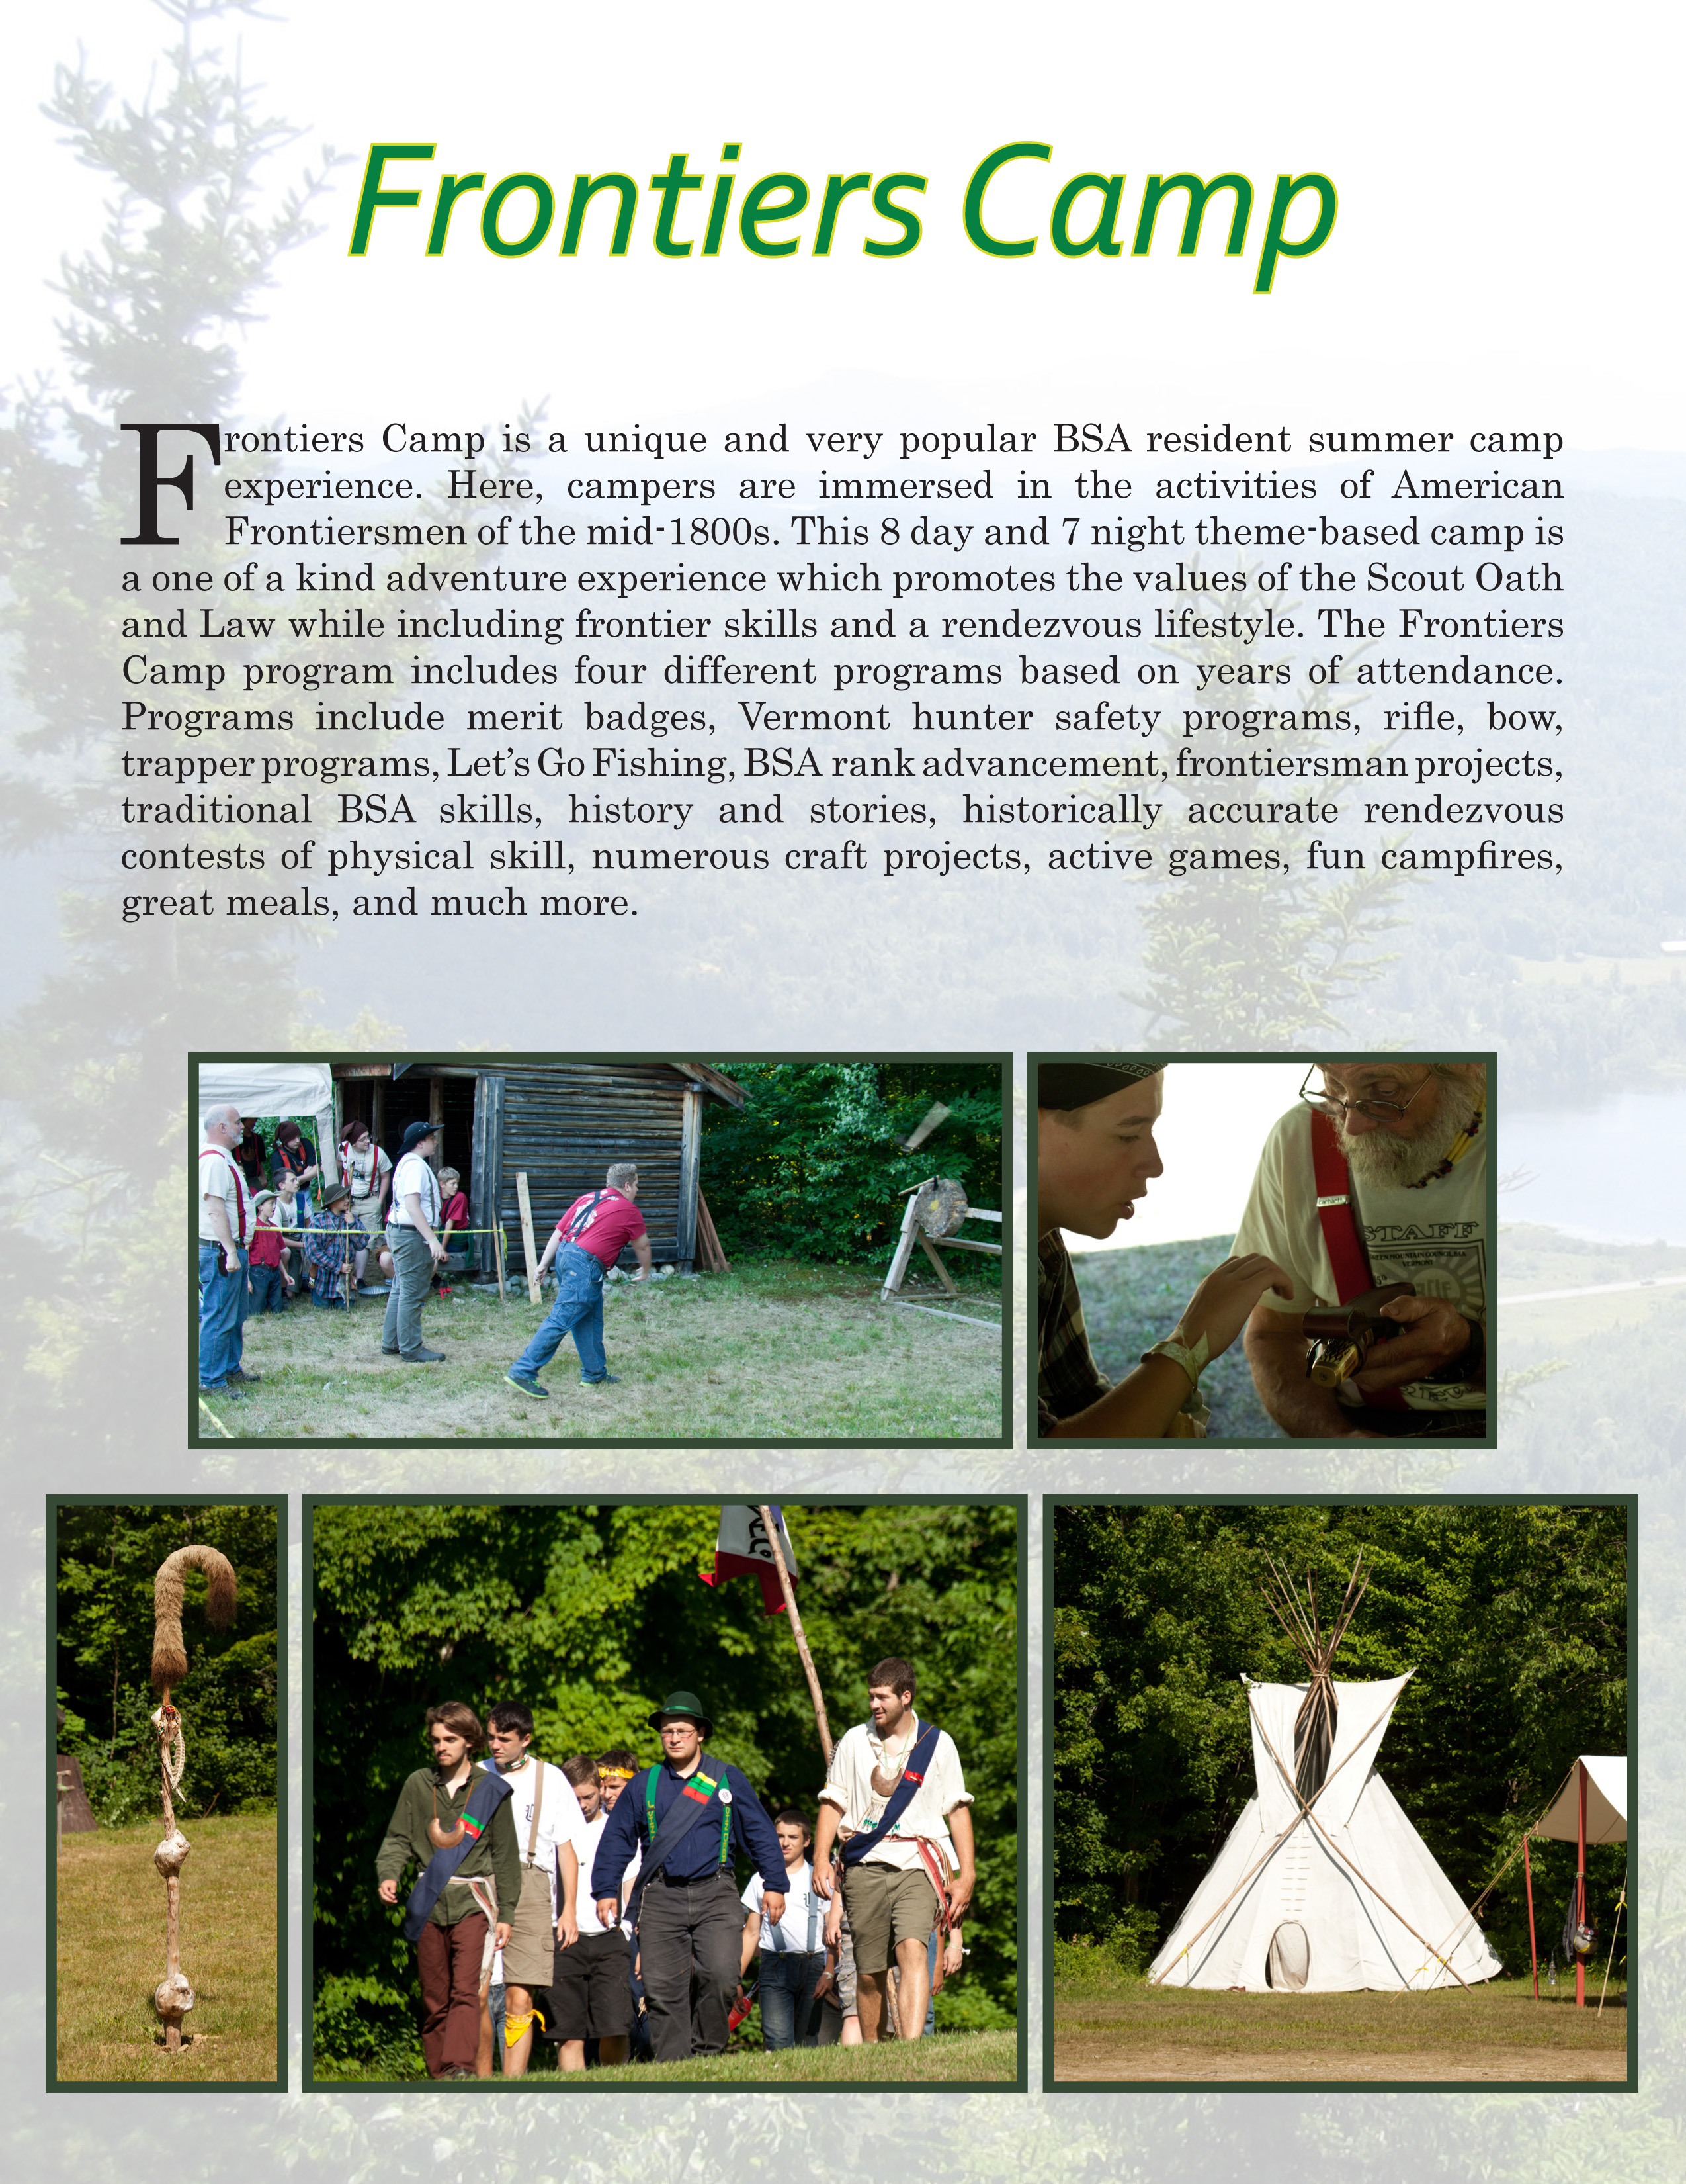

CAMP PROGRAM

PROGRAM PHILOSOPHY

It is the mission of the Green Mountain Council, Boy Scouts of America to prepare young people to make moral and ethical choices over their lifetime by instilling in them the values found in the Scout Oath and Law, and providing opportunities for achievement, advancement and leadership skills.

Scout camping provides the place, the leadership, and the programs to achieve the AIMS of Scouting. Summer camp provides an organized setting for a Scout to learn and practice these skills. Under his unit’s leadership and with camp staff support, Scouts are able to enjoy and experience a wide range of activities. The camp staff exists to serve your troop and to help your Scouts get the best possible experience at camp. Keep in mind, however, that the staff supplements your troop leadership-- it is not a substitute for it.

At the Green Mountain Council camps, we believe a good program reflects the needs, interests, and goals of the individual, patrol, and unit. We strive to achieve a good balance of advancement, outdoor skills, adventure, and learning activities to complement your year-round program.

SOME DO’S AND DON’TS ON CAMP PROGRAMMING

- DO set the tone that will give your unit real class. Insist on good manners, good fellowship, clean sportsmanship, clean fun, and a clean camp.
- DO require patrols to plan and carry out activities they plan.
- DO have enough programs to keep everyone busy.
- DO allow for and suggest some things to be done with a pal or two.
- DO be sure there is personal achievement, advancement, and FUN in the program.
- DO keep in personal touch with what’s going on in the unit.
- More than anything else, DO have fun!
- DON’T allow too much advancement to be planned by the individual Scout. Camping should be relaxing and fun, too.
- DON’T be alarmed if things happen that are not in the schedule. Some circumstances warrant changes in plans.
- DON’T judge the success of camp solely by advancement. Ask: did the Scout have fun?
- DON’T give boys a title and a camp leadership job and then do it all yourself.
- DON’T permit a camp violation or error in operation to persist or continue. Stop and show – correct the situation. A Scout camp is an outdoor classroom. Be kind but firm when necessary.

Do enjoy yourself and don’t hesitate to ask for help!!!

FIRST CLASS ADVENUTRE

First Class Adventure is a program for FIRST YEAR SCOUTS and is designed to teach the skills necessary to complete the Tenderfoot, Second Class, and First Class requirements. This is accomplished through a progression of skill training done in the First Class Adventure training area.

The Scoutmaster can use the program two ways. The First Class Adventure program will be held in two distinct time periods. A Scout cannot sign up for both time periods. There will be a morning session from 9:00 a.m. to 11:00 a.m. The afternoon session will be held from 2:00 p.m. to 4:00 p.m. The skills will be taught at the scheduled times so there can be a progression of learning; however, if a Scout has the skills for Tenderfoot and Second Class, he can work on First Class skills any time during the week. The skills are taught to the Scouts, but it is up to the Troop Leaders’ Council to test those skills.
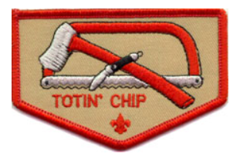
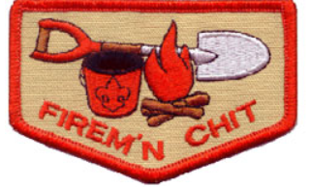
Monday evening, there will be a special campfire for all NEW scouts; Tuesday we do Totin’ Chip and Firem’n Chit; Wednesday a 5-mile hike with a trail lunch and on Thursday the Aquatics requirements (Scouts WILL get wet). It is highly recommended Scouts attend the 5-mile hike as several different requirements will be completed. Thank you for joining in on the Adventure!

SCHEDULE

Summer camp is an opportunity for Scouts to work on advancement requirements that are often difficult to accomplish outside of camp. We offer advancement opportunities for Scouts at any stage of their Scouting trail.

MT Norris has a program schedule that fits in as much “fun with a purpose” as possible and at the same time provides flexibility enough to serve participants of various ages, experience, and skills. Mornings from 9:00 a.m. until 12:00 noon are activity blocks I and II. Some morning programs, merit badges, or activity sessions will be three hours and take both blocks, others will take an hour and a half; block I or II. Afternoons from 2:00 p.m. until 4:00 p.m. is activity block III. We recognize some merit badges will not take more than one block, and are generally flexible when it comes to when merit badges are offered. Always communicate your needs with our area directors.

Evenings from 7:00 p.m. until 9:00 p.m. will have one or two different activities of varying duration depending on the weekday and the activity.

Flag ceremonies will take place before breakfast and before dinner; 7:50 a.m. and 5:50 p.m. respectively.

Throughout the week, we will schedule activities that strengthen the patrol method, such as; competitions to enhance team building and to strengthen the bond between Scout Troops from around the state and the region.

Friday’s schedule will offer Scouts an opportunity to catch up on merit badge requirements, learn new activities, hike to the summit of Mt. Norris and participate in a camp-wide game.

ACTIVITY SESSIONS AND SIGN UP

To ensure the quality of activity sessions we are offering either 1.5 or 3 hour sessions. These will be held from Monday through Thursday. Friday will be an adventure day specifically set aside for fun and camp-wide games!

Some merit badges will not require more than one session (e.g. many of the handicraft merit badges). Other merit badges will require all eight sessions (e.g. Small-Boat Sailing, and Pioneering, among others). The estimated time will be listed on the pre-registration materials provided to registered units in early-April.

Time | Sunday | Monday | Tuesday | Wednesday | Thursday | Friday | Saturday
6:30 a.m. |  | Polar Bear Swim
7:00 a.m. |  | Reveille
7:50 a.m. |  | Morning Colors |  |  |  | In-site breakfast Colors at 9:00 a.m. | Continental breakfast
8:00 a.m. |  | Breakfast; family style
8:30 a.m.
9:00 a.m. |  | Morning sessions I |  |  |  |  | Have a safe trip home
9:30 a.m.
10:00 a.m.
10:30 a.m. |  | Morning sessions II
11:00 a.m. |  |  |  |  |  |  | Staff’s day off begins
11:30 a.m.
12:00 p.m. |  | Lunch; buffet style
12:30 p.m.
1:00 p.m. | In-processing: Office check-in, medical and swim check, camp tour | Siesta
1:30 p.m.
2:00 p.m. |  | Afternoon sessions
2:30 p.m.
3:00 p.m.
3:30 p.m.
4:00 p.m.
4:30 p.m.
5:00 p.m.
5:50 p.m. | Retreat Flag Ceremony
6:00 p.m. | Dinner; family style |  |  |  | Dinner in-site | Cook-out, families welcome
6:30 p.m.
7:00 p.m. |  |  |  | Vespers | Troop time | 7:15 p.m. Closing campfire
7:30 p.m.
8:00 p.m. | Opening campfire
8:30 p.m.
9:00 p.m.
9:30 p.m. | Site-check
10:00 p.m. | Taps and Lights-out
Schedule framework; additional details and updates will be provided as they become available.

SELECTING MERIT BADGES

A Scout is at camp to have fun, not to be frustrated with incomplete merit badges. Camp is about each scout having fun, learning leadership skills, advancing in rank and learning new skills. Please make sure the Scouts and leaders keep this in mind as they choose merit badges.

Selecting merit badges depends on a variety of factors: the Scout’s age, abilities, and the troop’s year-round program. A review of individual Scout advancement desires and needs is suggested to be completed by late April. A pre-registration will be mandatory! If a unit does not participate in the pre-registration process MT Norris cannot guarantee a Scouts desired merit badge session will be available. During these planning sessions, distribute the degree of difficulty and the list of suggested requirements to be completed at home. Boys should be instructed to choose through the list of available merit badges that he wants to earn in his week.

MERIT BADGE PREREQUISITES (work that cannot be done at camp)

The staff at MT Norris takes pride in the fact that every skill needed for a badge at camp is truly mastered. No merit badge requirements can be waived to make up for the fact that it cannot be completed in a camp situation. Every skill must be met for the merit badge to be earned, including those requirements that cannot be done at camp. A Scout can bring his work to camp on these requirements and complete the merit badge or he can finish the work at home. It is recommended that Scouts complete any requirements that they can before arriving at camp, particularly requirements that require extensive writing, extended record keeping, visits to specific events or places, etc. Scouts should bring their work or proof of their work to camp. Only in a few circumstances should unit leaders expect Scouts to complete written reports, letters, etc. while at camp. Please advise your Scouts that these need to be completed and brought to camp for submission to the appropriate merit badge counselor.

Tentaroo is the council’s on-line registration for merit badges. It has the most up to date merit badge offerings and is to be used by all units when signing Scouts up for the merit badges offered at camp. Instructions are in the appendix of this guide. If your unit doesn’t already have access, contact the council service center to receive a user name and password. To access the site go to https://www.tentaroo.com/greenmtn/

NATIONAL 2017 MERIT BADGE OFFERINGS
(Subject to change – all updates will be on the MT Norris webpage.)

AQUATICS | HANDICRAFT | ECON | SCOUTCRAFT | SHOOTING SPORTS | OTHER
Canoeing | Leatherwork | Environmental Science | Wilderness Survival | Archery | First Aid
Swimming | Basketry | Forestry | Orienteering | Rifle Shooting | Emergency Prepared-ness
Small Boat Sailing | Art | Energy | Camping | Shotgun Shooting
Rowing | Sculpture | Nature | Cooking
Lifesaving | Wood Carving | Gardening | Pioneering
Kayaking | Indian Lore | Weather

COUNSELOR-IN-TRAINING (CIT) PROGRAM

The CIT (Counselor-in-Training) program is for Scouts who are 14 years of age by June 1st. Scouts interested in participating in the program should submit a staff application to the camp director. The program is geared to recruit potential staff members and expose them to the many facets of the summer camp program while grooming them for positions as staff members. The training syllabus is developed to teach them the various skills needed to be a successful staff member. Part of the training involves working alongside the program staff in their assigned areas. Time is allotted for work on merit badges.

The program runs over a single week period. Scouts who successfully complete the Counselor-In-Training program may be invited to return as interns for the duration of the camping season. At the end of the week, an evaluation of the CIT will be conducted to determine their qualification for future work at camp as a staff member.

CONSERVATION PROJECTS

Each troop is encouraged to participate in a conservation project at camp. A list of conservation projects has been compiled according to the Camp Conservation Plan. Please seek out the camp commissioner or camp ranger for a project. Projects include erosion control, stream improvement, forestry, perimeter trail development, and wildlife habitat enhancement. Please receive approval for all site improvements from the camp commissioner or ranger before beginning any project(s).

YOUTH LEADER'S COUNCIL

The youth leaders’ council meets twice a week and is an opportunity for the Troop leadership to meet with the program director and discuss any needs they may have. They can plan the “Special Program Activities” and any “camp-wide games.” They will also work on the Friday evening campfire. Some “Special Program Activities” might be: a dusk canoe/kayak hike looking for loons, a camp-wide Capture the Flag, or a troop vs staff activity. Your troop youth leadership decides a significant part of the day-to-day program opportunities. They are strongly encouraged to bring new suggestions and ideas to the table.

LEADER'S PROGRAM

In general, most activities available to Scouts are available to leaders as well, including a weekly horseshoe tournament. Adults are eligible to earn the Mile Swim and BSA Life Guard. In addition, the following training opportunities are available: Youth Protection Training, Safe Swim Defense, Climb on Safely, Safety Afloat, and Trek Safely. Leaders 18 and over can earn the Scoutmaster’s merit badge (see following page for details).

ORDER OF THE ARROW IN CAMP

The Order of the Arrow (OA) is an honor society for Scouts elected by their peers because of demonstrated leadership and camping ability. There are representatives of the Brotherhood in camp. They are available to talk to you and your Scouts about the Order of the Arrow. The Order of the Arrow service project will occur on Wednesdays during siesta, and Wednesday evenings the OA hosts a cracker barrel in the dining hall. Members of the OA who have been an Ordeal member for at least 10 months may complete their Brotherhood conversion in camp on Wednesday night. Ask the OA camp chief for more information and to sign up.

FRIDAY EVENING PROGRAM

We will kick off our Friday evening with a cook-out at 6:00 p.m. Visitors are welcome; however we ask that units provide reservations for extra meals to the camp director upon check-in. Visitors must follow camp visitor policy and report to the camp office upon arrival in camp. Campfire will begin at 7:15 p.m.

COOK-Out visitor tickets are available at the camp office or Trading Post.

Visitors 12 years and older | $10.00 each
Visitors 6 years to 11 years | $7.00 each
Younger than 6 years | Complimentary

SCOUTMASTER'S MERIT BADGE

MT Norris is pleased to announce the continuation of the Scoutmaster’s merit badge for the 2017 camping season. This special merit badge is only available to adult leaders that attend the 2017 camp.

The purpose of this program is three-fold. We realize that there are troops that come to camp with many leaders. Many of these leaders may have spare time during camp and are always up for the challenge to “do a good turn daily.” Leaders are always looking to update their training to provide a great program for their troop. And, as the staff at MT Norris may fluctuate each week, some areas may need another hand depending on camp numbers.

In order to receive this award, there are requirements just like the Boy Scout merit badges. Completed requirements need to be kept track of and signed off by the appropriate staff member. These signed sheets should be handed in to the camp commissioner by noon on Friday. Adult leaders that take part in this program will receive their award at the closing ceremony on Friday night.

OTHER CAMP AWARDS

MT Norris is pleased to add the Troop participation award to the 2017 camping season. This award is available to multiple troops that meet a set of requirements that demonstrate excellent camp-wide participation and Scout spirit. The Individual Scout spirit award is available to multiple Scouts upon the recommendation of the staff and the Scout’s unit’s leadership.

LEADER’S PRE-CAMP CHECKLIST
Check off this list as you complete each task as part of your planning.

- Working with your troop committee, recruit and train assistant camp leaders.
- Schedule your troop’s parents’ night and present Camp information.
- Using pre-registration materials, make sure all Scouts register for activity sessions before June 15th.
- Complete a roster of all Scouts going to camp. Do you have all the last minute ones?
- Turn this roster into the Council Service Center two weeks before arrival at camp.
- Names, addresses, and phone numbers of all parents. Do you know where they can be reached in an emergency?
- Health and medical record forms for each Scout and leader. No Scout or adult may register or remain in camp without one. Medical forms need all immunization dates, parent, and doctor signatures.
- All transportation arrangements made both to and from camp.
- Troop camping and program equipment (including troop and American flags, tarps, and cooking equipment)
- Each Scout is properly equipped (See checklist! Have an equipment check just before camp! Discourage boys from being over-equipped.).
- All pre-camp program planning is completed and leader has necessary information and records--Scout advancement goals--troop analysis (which youth leaders are going to camp, number of patrols, who cannot swim, etc.)
- Camping patrols have elected their leaders.
- All parents aware of plans--date, time, and place of departure, return date, time, and place of arrival, mailing and phone information, visiting day rules, Friday evening BBQ etc.
- All Scouts and leaders properly uniformed (have summer uniform inspection at a troop meeting prior to camp). Leader has sufficient funds for emergencies.
- Troop First Aid Kit in good condition and ready to go.
- All tent assignments made on patrol basis (plan on 2-man tents).
- Troop SPL (or camp SPL elected) will be in camp.
- Balance of all fees paid.
- Troop committee has contacted parents of all Scouts not signed up for camp.
- Final Troop leaders’ meeting; check on any last minute program changes and updates.
- All papers ready:

TROOP EQUIPMENT LIST

Already in camp sites
- Two-person canvas wall tents on a platforms. (see page 9)
- Cots
- Dining fly
- Picnic Table(s)
- Latrine
- Multi-spigot washstand (cold water)
- Bulletin board
- Flagpole
- Campfire area
- Rake
- Shovel
- Hose
- Scrub-brush

Available from the Quartermaster

- Toilet paper
- Latrine cleaning supplies
- Binder twine (for improvements)
- Bow saws
- Rakes
- Shovels
- Dutch ovens (limited quantity)
- Ask … we’ll be happy to help!

Suggested troop equipment to bring

- U.S. flag for Flag pole
- Troop flag
- First Aid kit
- Lantern (battery)
- Saws & axes
- Dutch oven, reflector oven
- Spices
- Percolating coffee pot
- Merit Badge book library
- Leaders Guide
- Tents, if staying in Mt. Ellen or exceeding capacity in other sites.
- Stew pot
- Cooking utensils

Suggested equipment for troop leader to bring

- Alarm clock (wind-up / battery)
- Radio for weather reports
- Lawn chair
- Lantern
- Clipboard
- Thumb tacks
- Troop merit badge pamphlets
- Troop advancement reports
- Medical forms, copies for all
- Swim test records
- Camp payment receipts
- Troop checkbook
- Troop insurance information
- Pre-camp planning paperwork

- Have vacation phone number of any parent/spouse who will be away during camp.
- It is advisable to bring a copy of each medical form: the original to turn in, a copy for your reference.
- Planning brings a good camp experience!
PERSONAL EQUIPMENT LIST
This is a suggested list of equipment for an enjoyable stay at camp. It does get rather cool in the evenings and each boy should be prepared for this. Also, footlockers are recommended over duffel bags and packs, as they are easier to keep organized, can be locked, and may slide right under the bunks. It is a good idea to label items with your name and troop number.

Clothing Useful Equipment
□ Complete Scout uniform □ Sunglasses
□ Underwear □ Sun Screen
□ Socks □ Daypack
□ T-shirts □ Knife, fork, & spoon
□ Long pants □ Flashlight (extra batteries)
□ Beach towel □ Mess kit, canteen
□ Swim trunks □ Boy Scout Handbook
□ Jacket □ Pen, pencil, and notebook
□ Rain gear □ Compass
□ Handkerchiefs □ Insect repellent
□ Extra sneakers
□ Hiking boots

Bedding Optional Equipment
□ Sleeping bag or 2-3 warm blankets □ Camera
□ Air mattress or foam pad □ Bible / Prayer book
□ Pillow □ Mending/sewing kit
□ Toothbrush, toothpaste □ First Aid Kit
□ Soap & towels □ Fishing tackle
□ Stationary & stamps □ Trading Post spending money (small bills!)

PROHIBITED ITEMS
The Camp Leadership reserves the right to confiscate and prohibit items from either campers or adults.

Fireworks Pets
Alcohol Firearms
Archery equipment Ammunition
Illegal Drugs / Marijuana Chain Saws
Knives with blades over 3” or fixed blades

Troop leaders are responsible for the supervision of their troop’s youth and are not permitted to leave camp for the purpose of consuming alcoholic beverages, nor return after consuming alcoholic beverages.

Mt. Norris Scout Reservation Alumni Assoc.
“Kitted” Camp Improvement Projects
Picnic Table
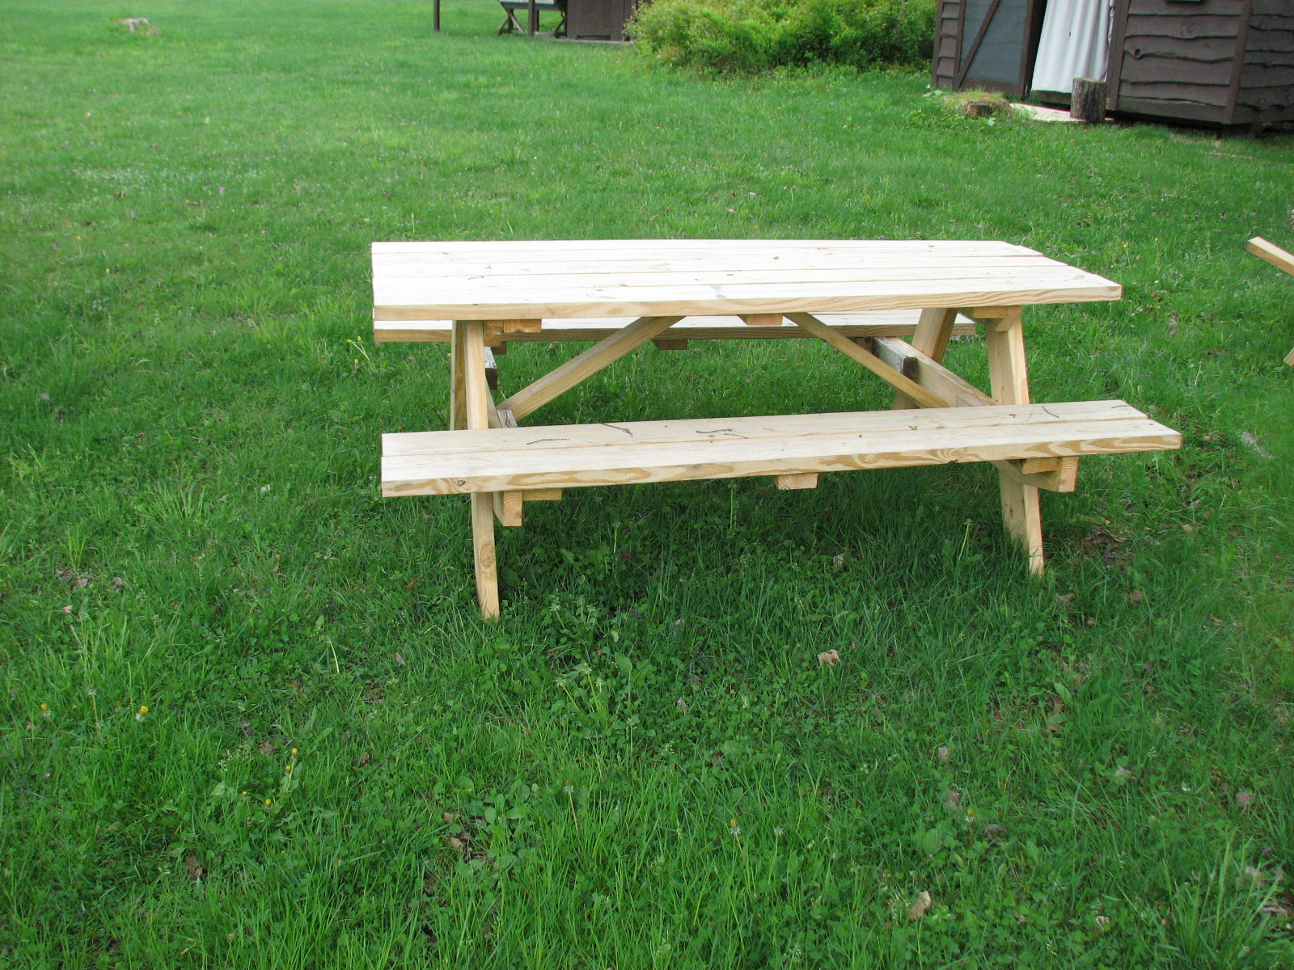
Camp Site Bulletin Board
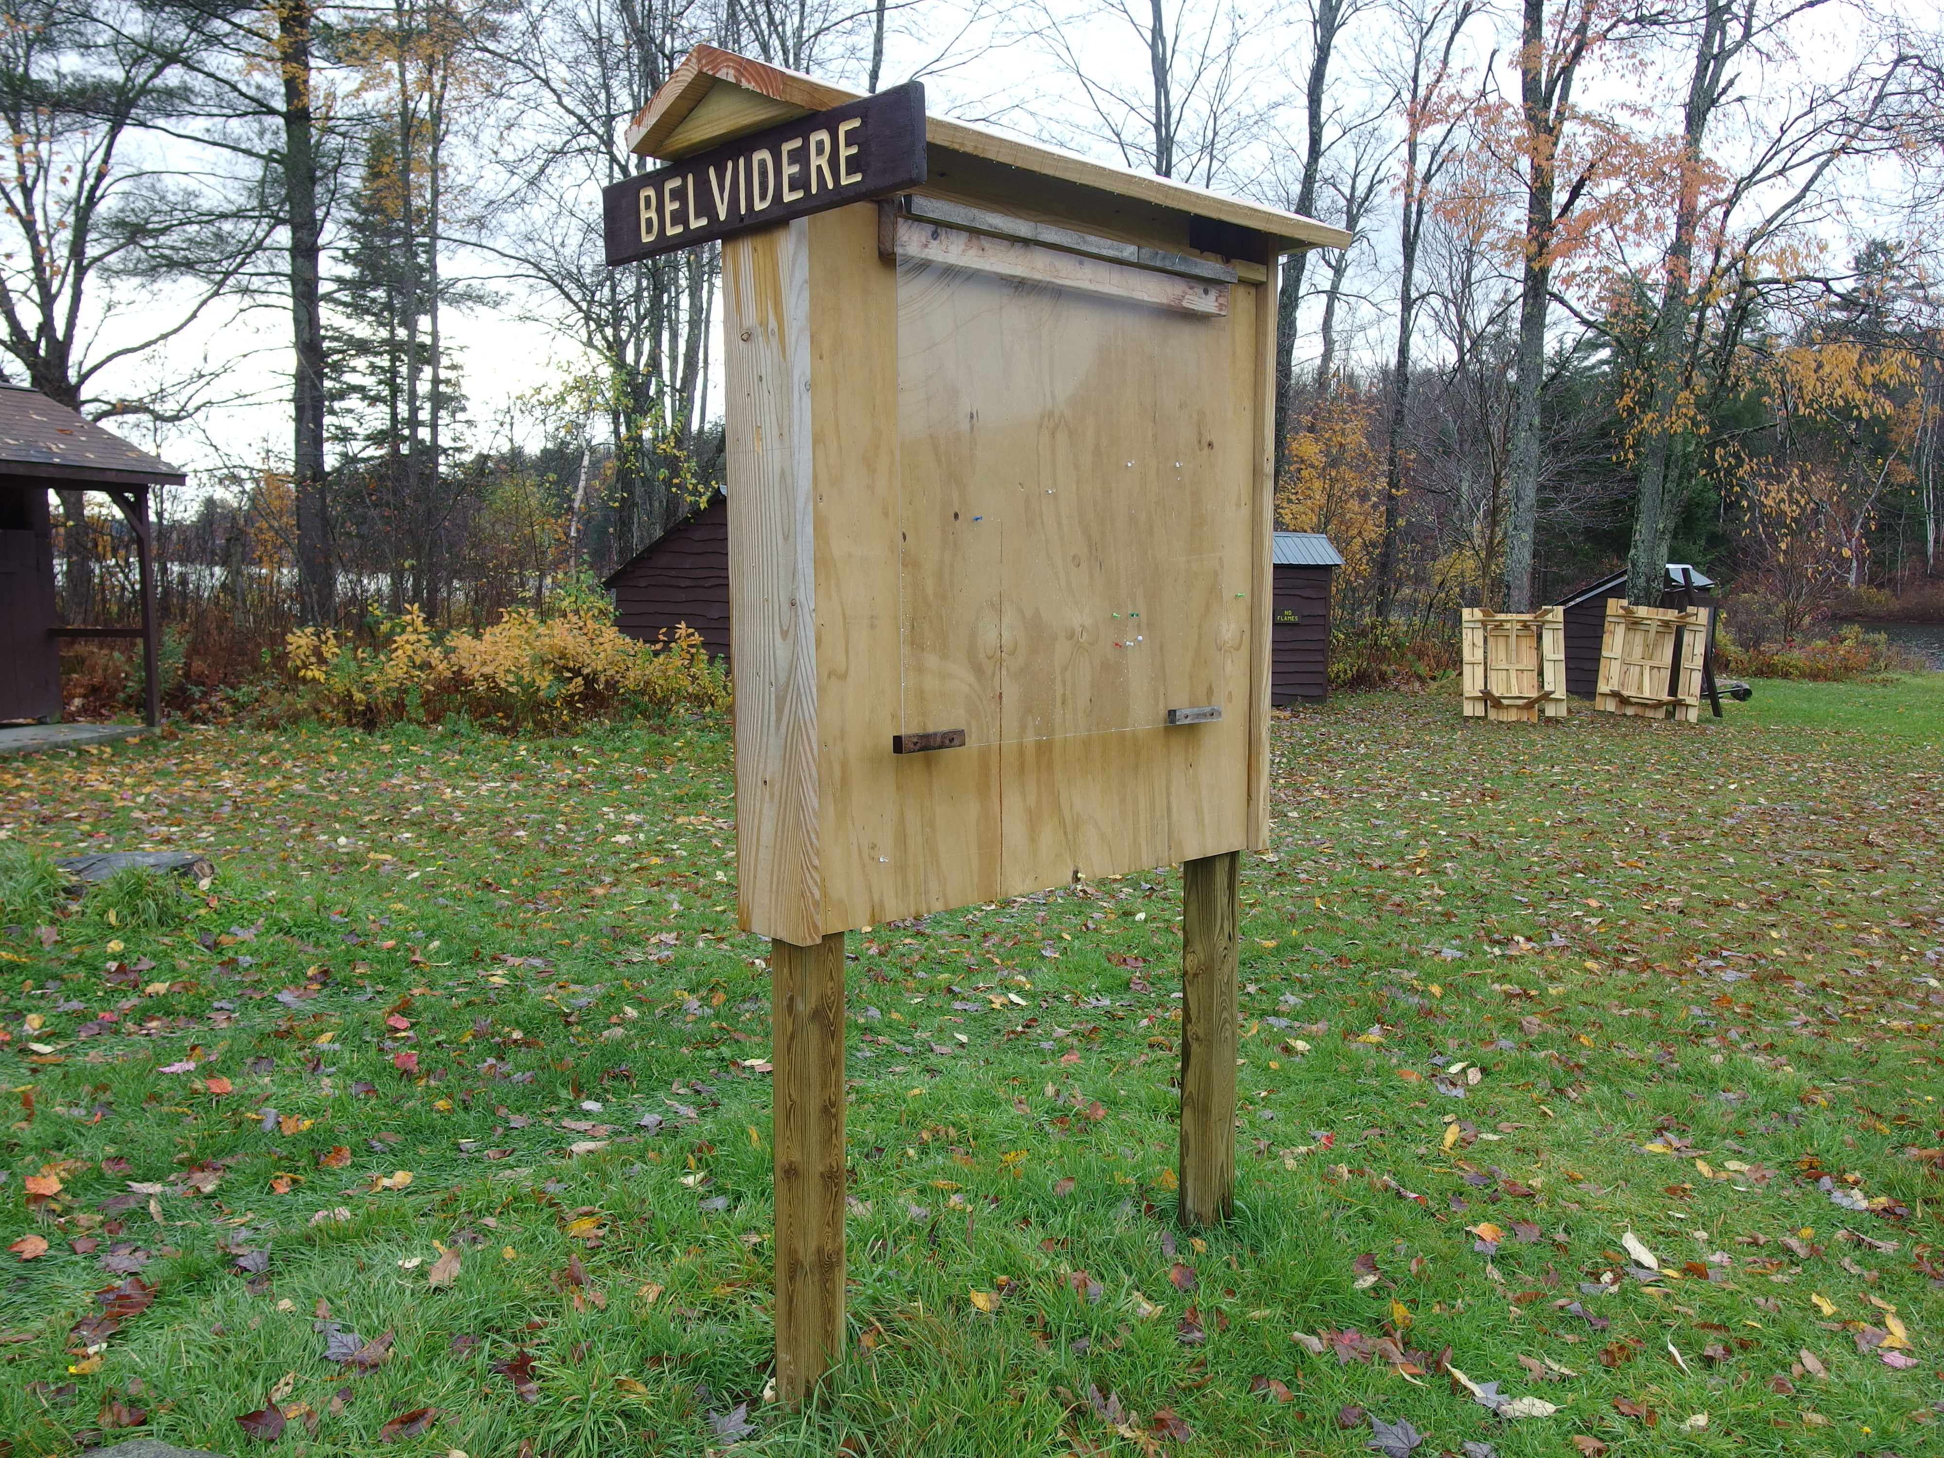
Campfire Bench
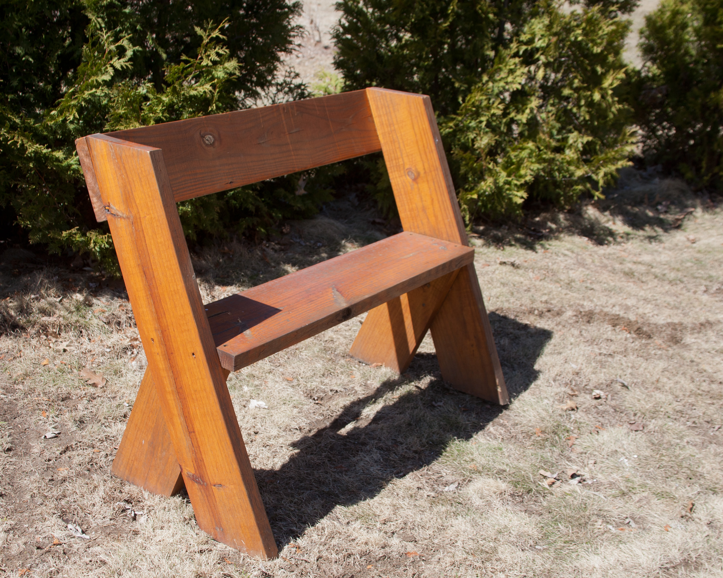
Waterfront canoe racks
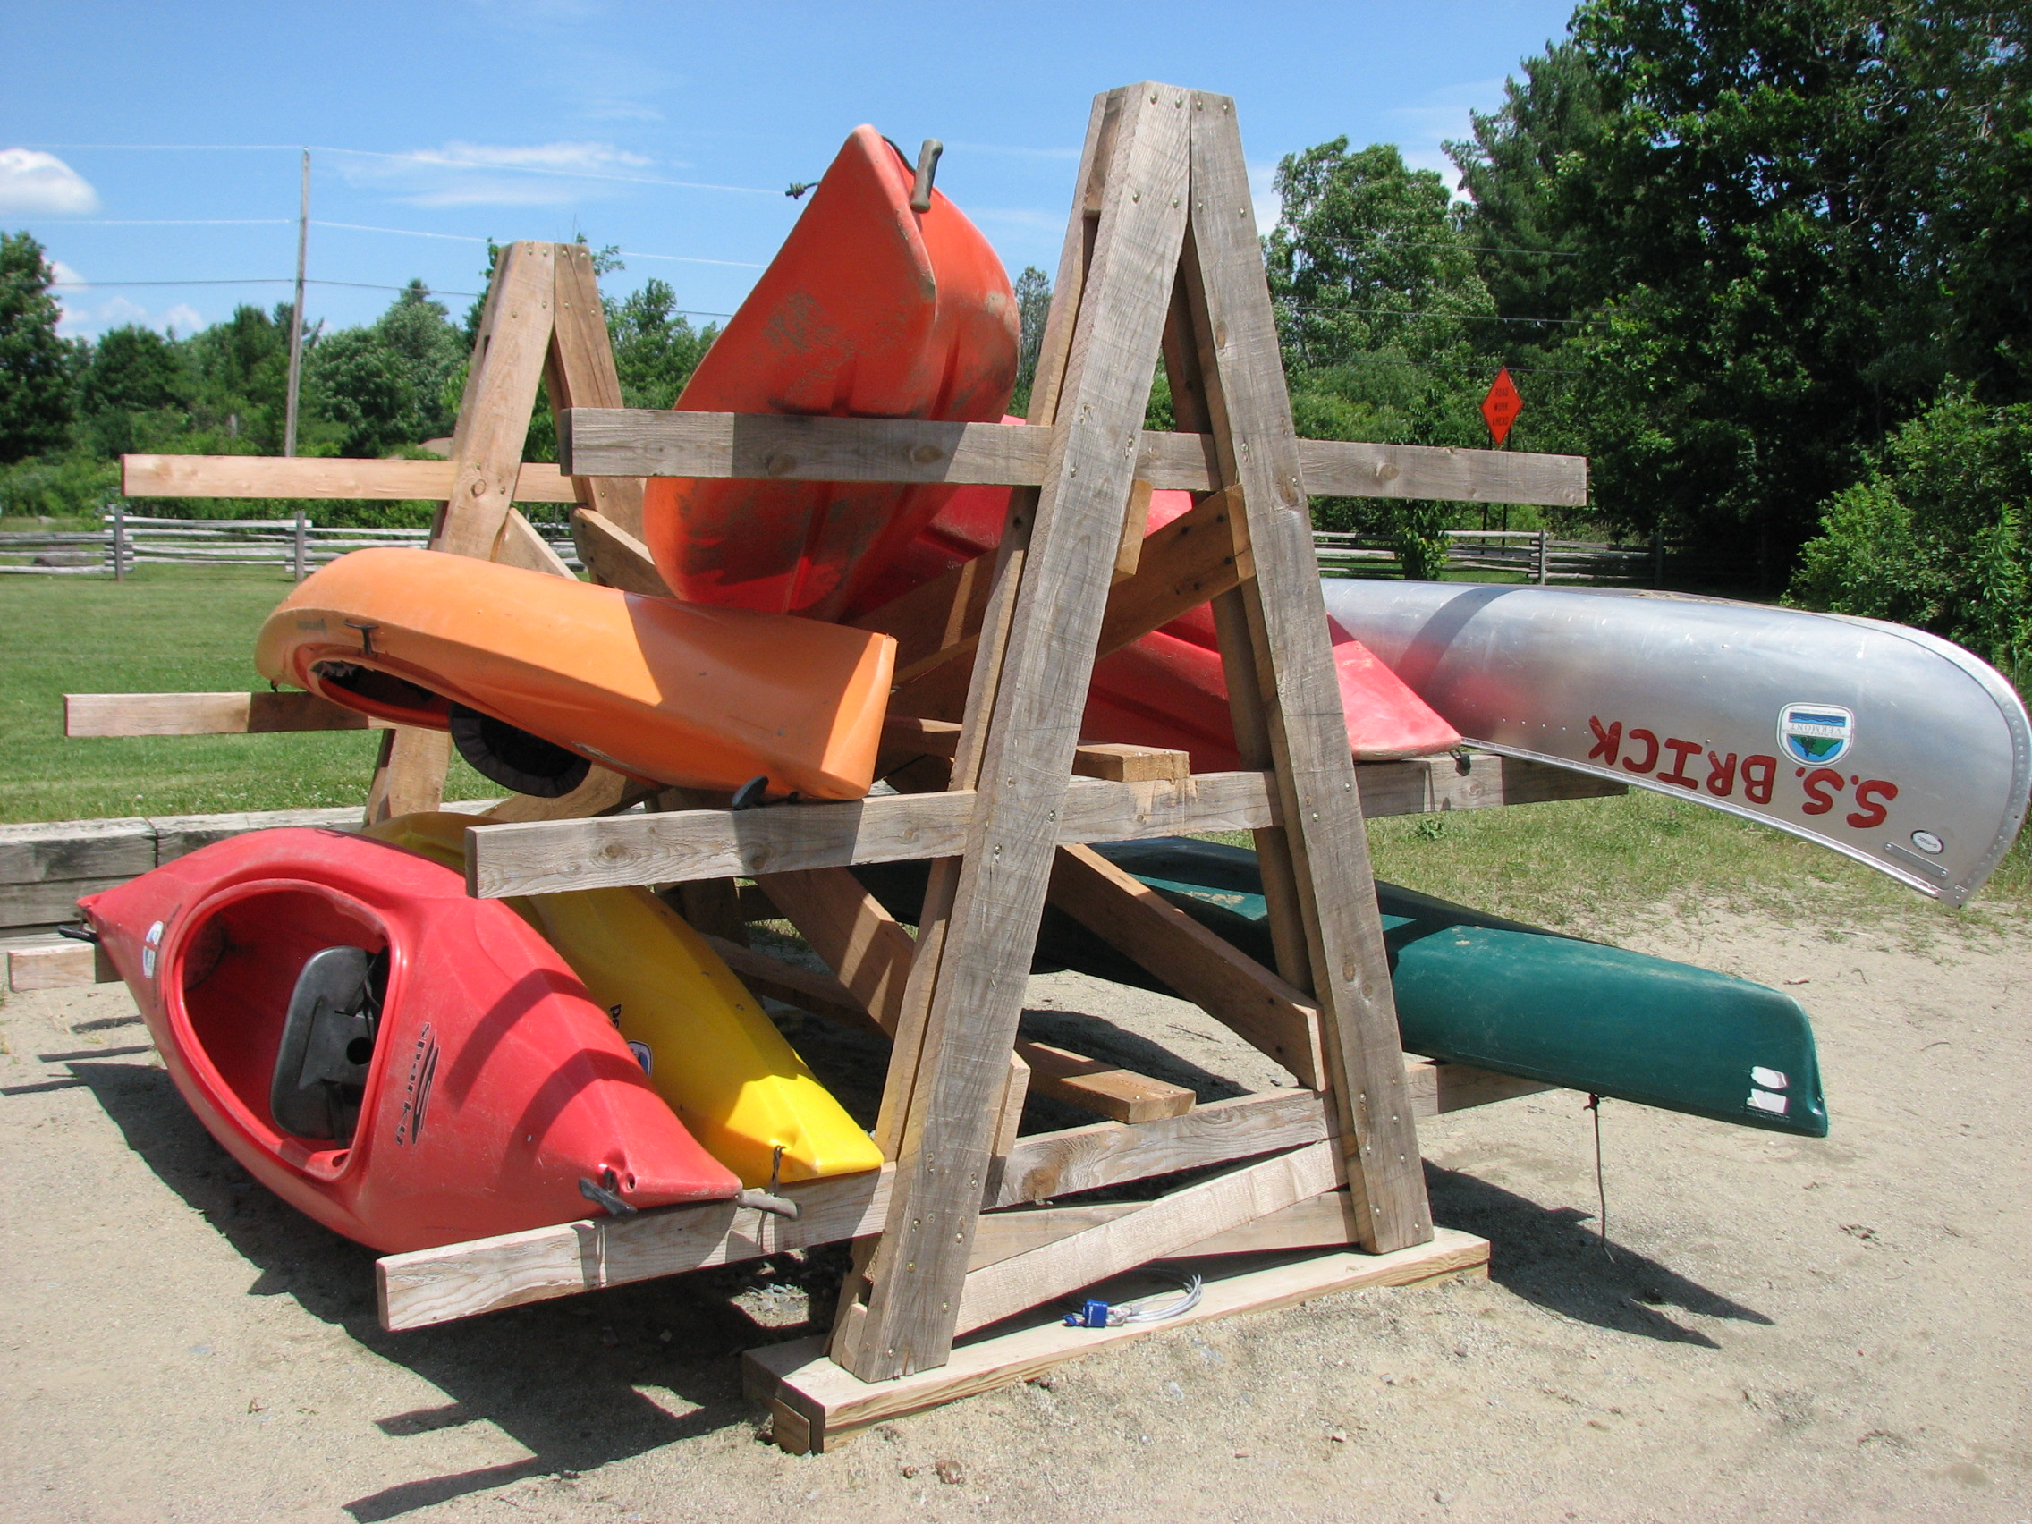
Traffic Barrier
Tent Platform Outriggers
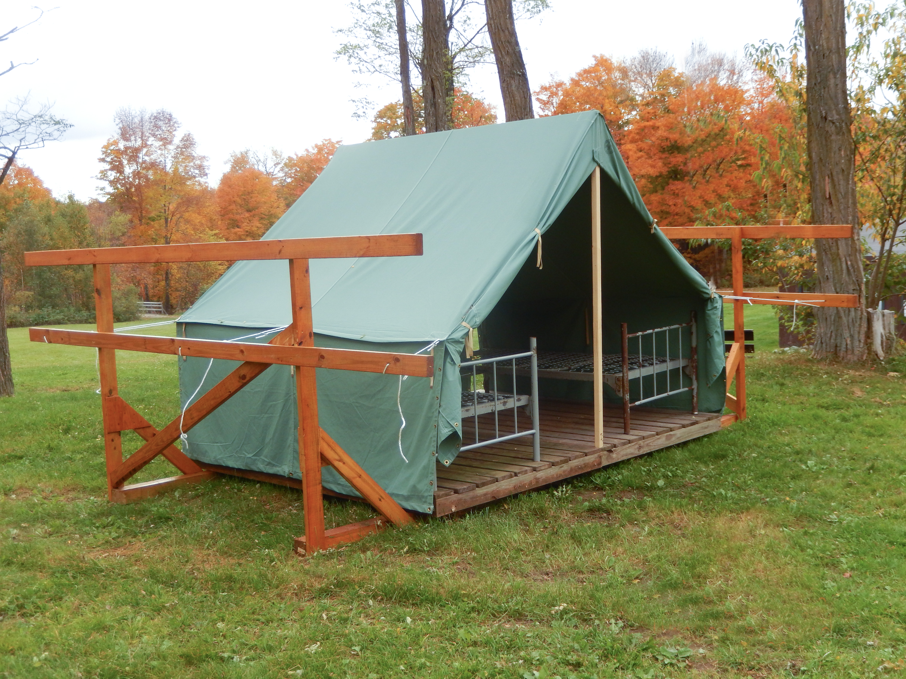

Straight Bench
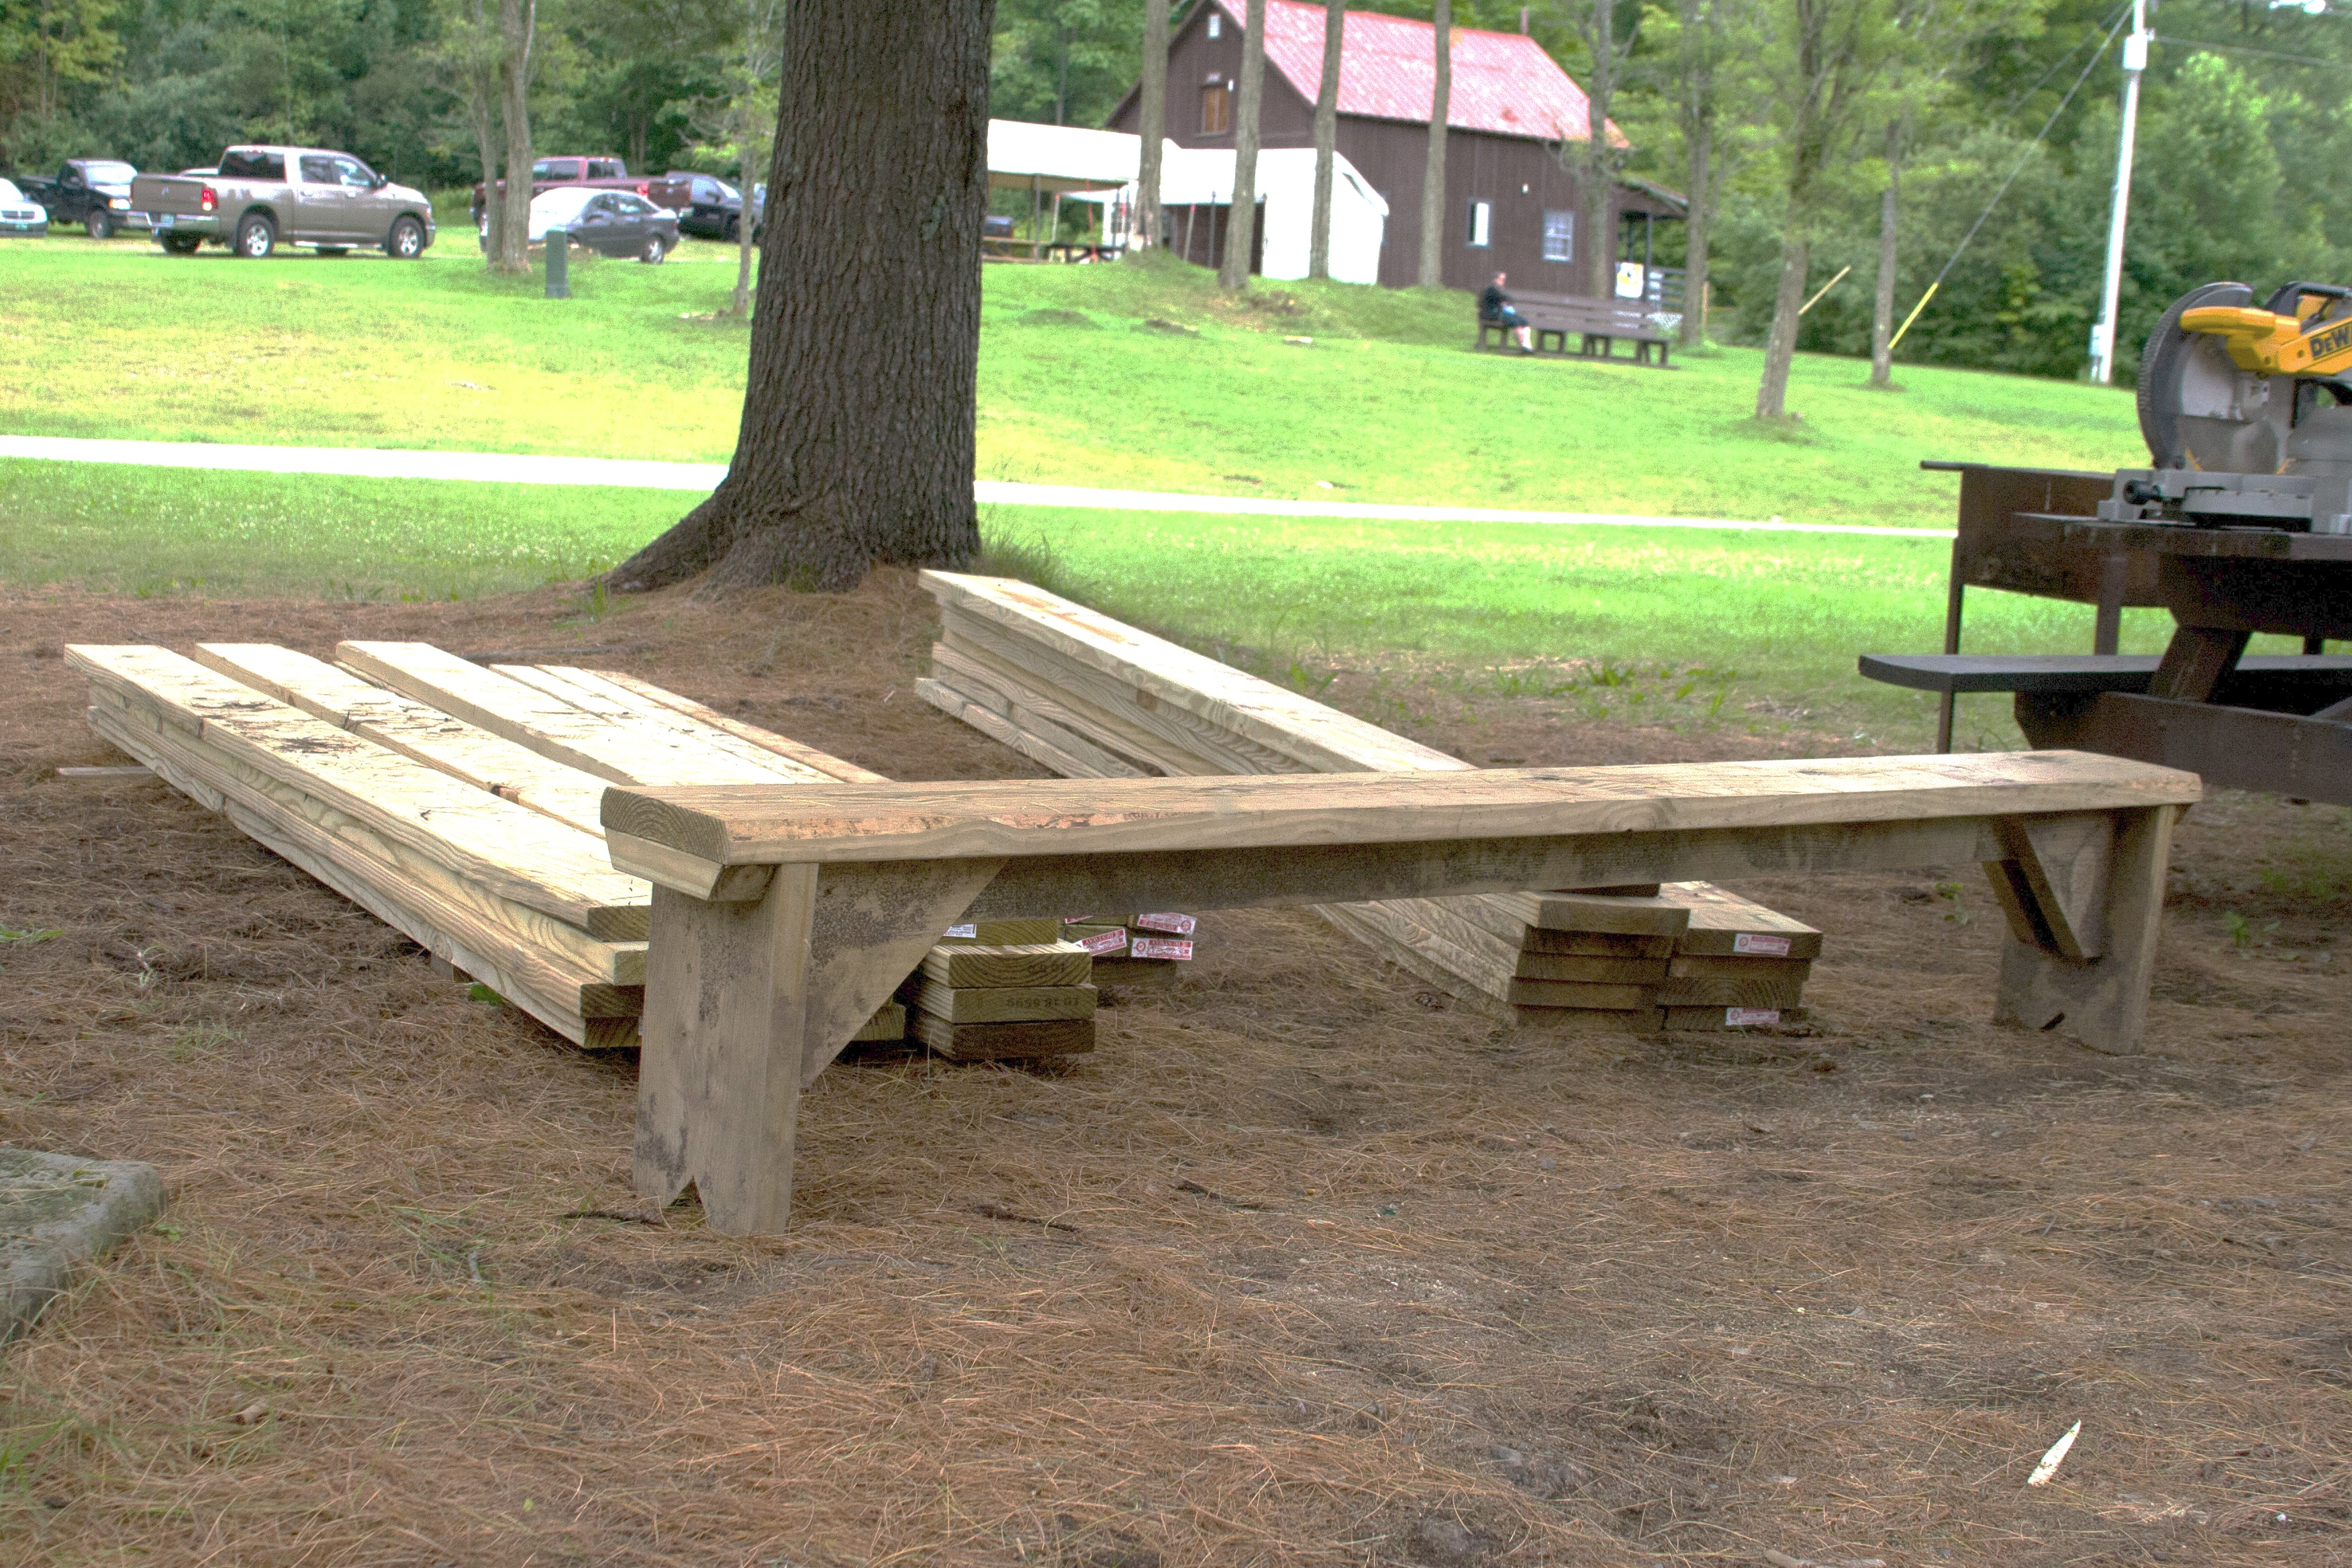
Waterfront Bench
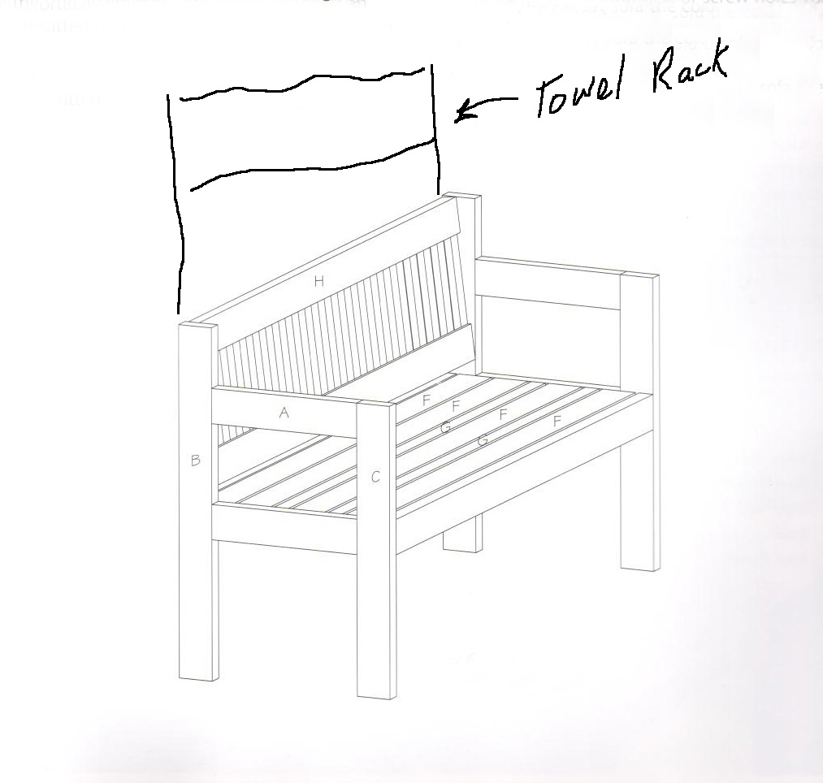
To ensure consistent design, the Alumni Association has prototyped most of these projects and will provide the materials. You come to camp prepared to assemble one or more projects. Plan ahead; email the Alumni Association to arrange materials and plan needed tools.

Mtnorrisalumni@gmail.com

APPENDIX (additional forms and information)

Annual Health and Medical Record forms A, B, and C

Routine Drug Administration Record form

Tentaroo Instructions

Scout [Early] Release Request

Mt Norris Scout Reservation Alumni Association Info

MNSRAA membership application

National Youth Leadership Training

Camp Map

In and Out Processing Checklist (in work)

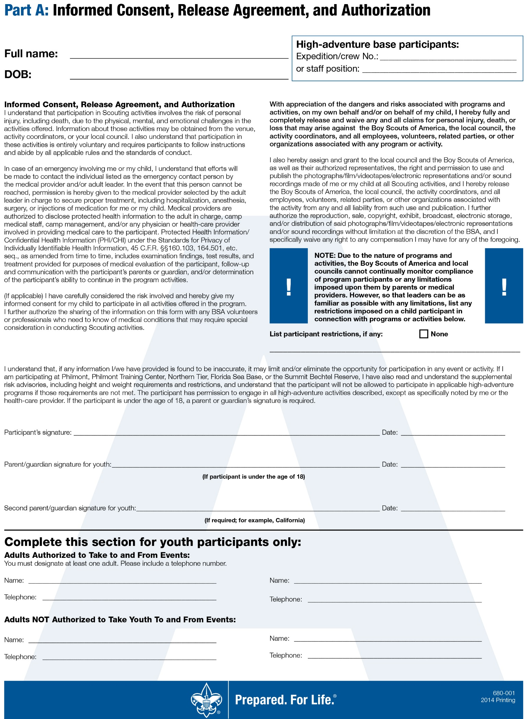
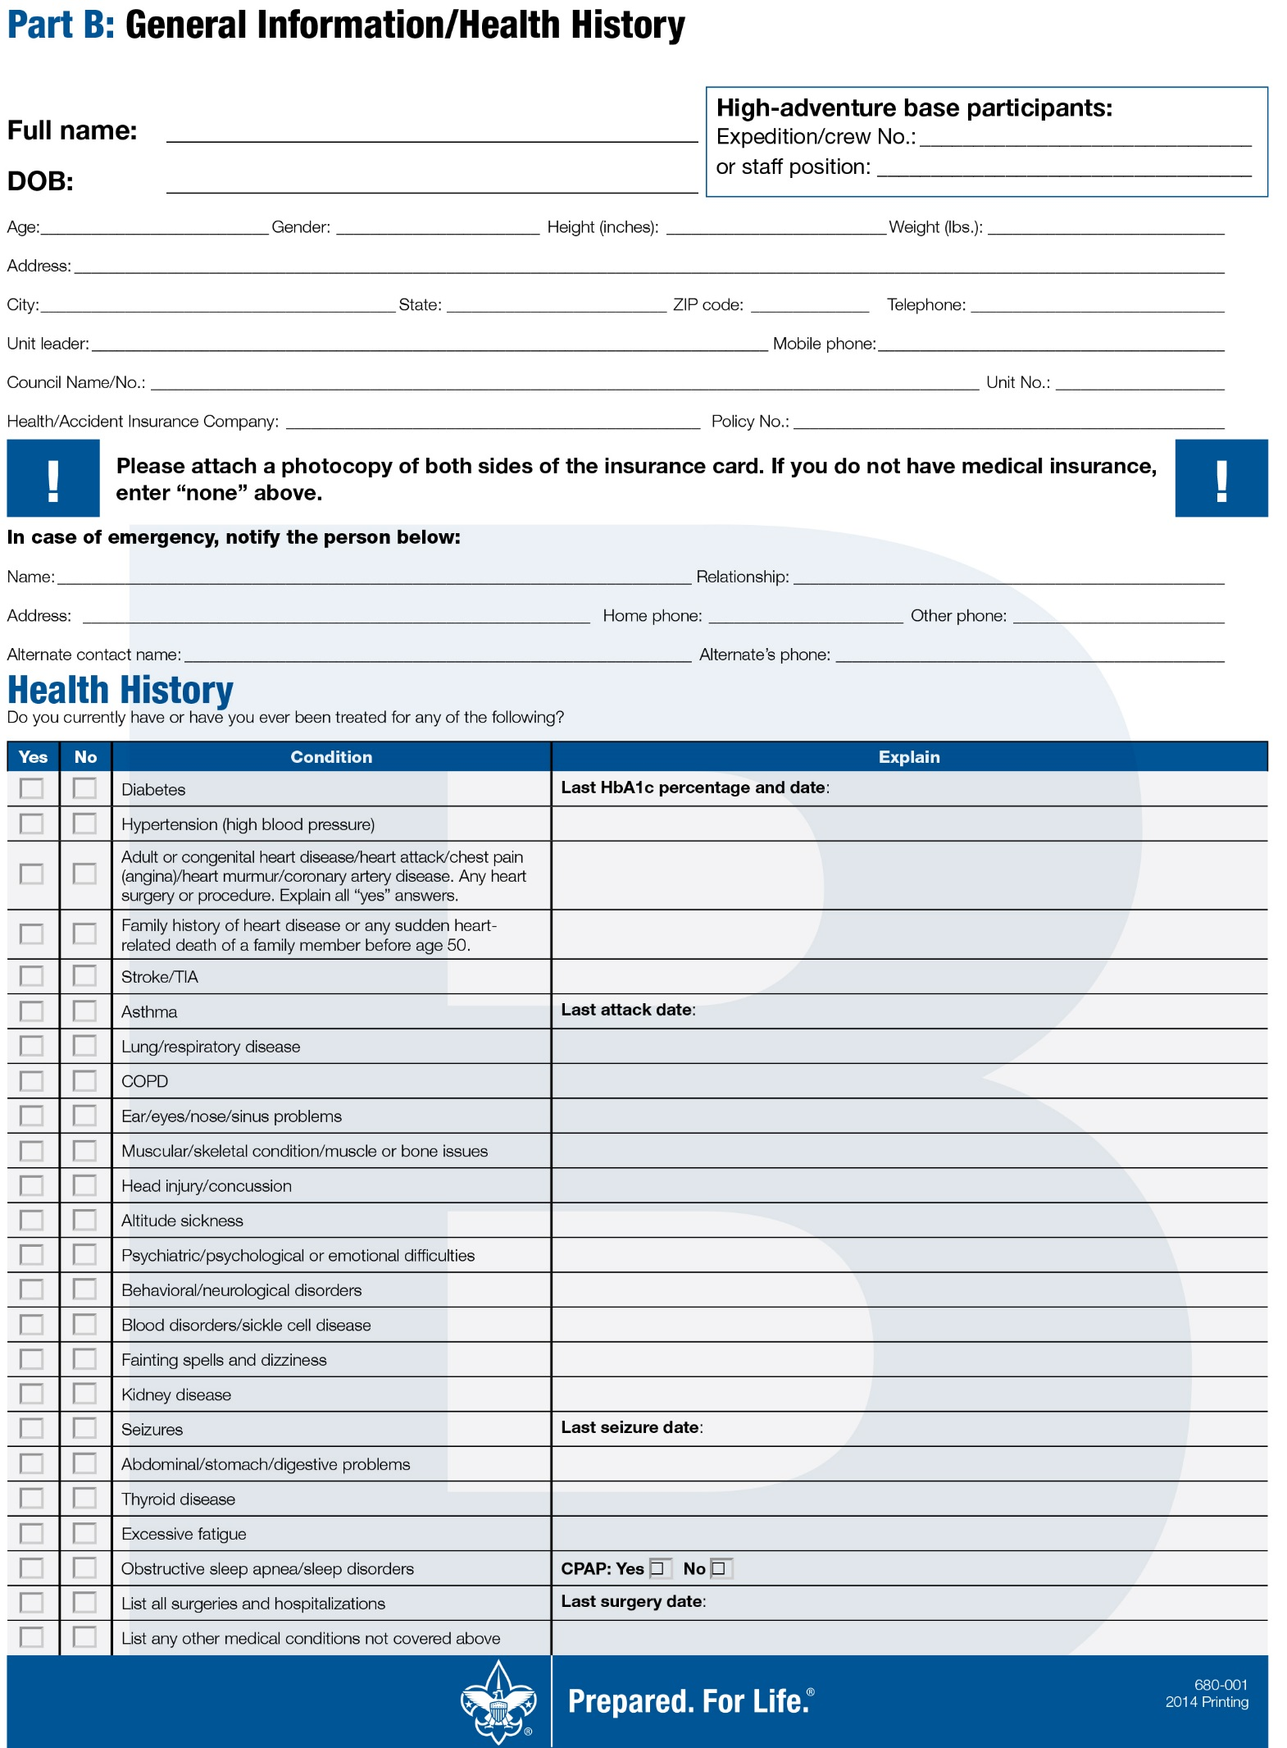
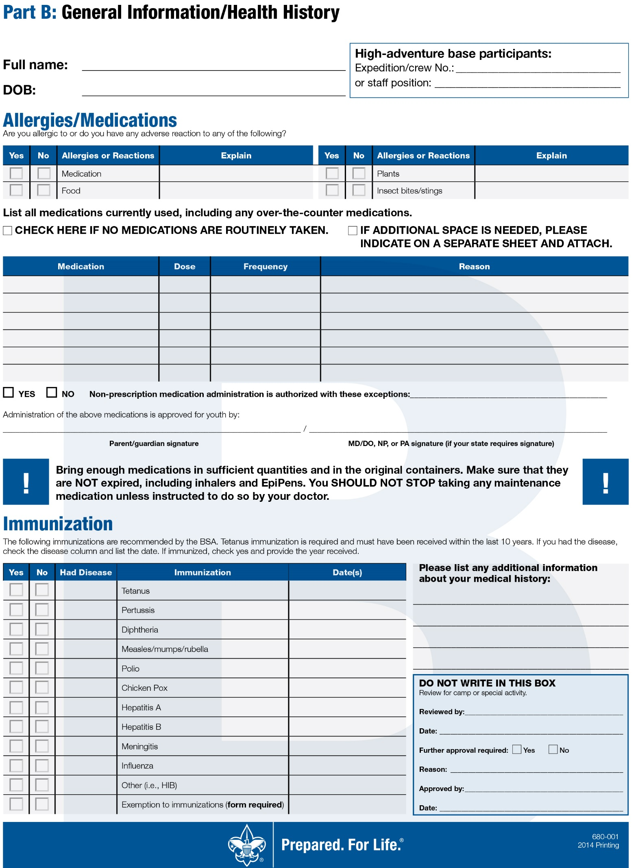
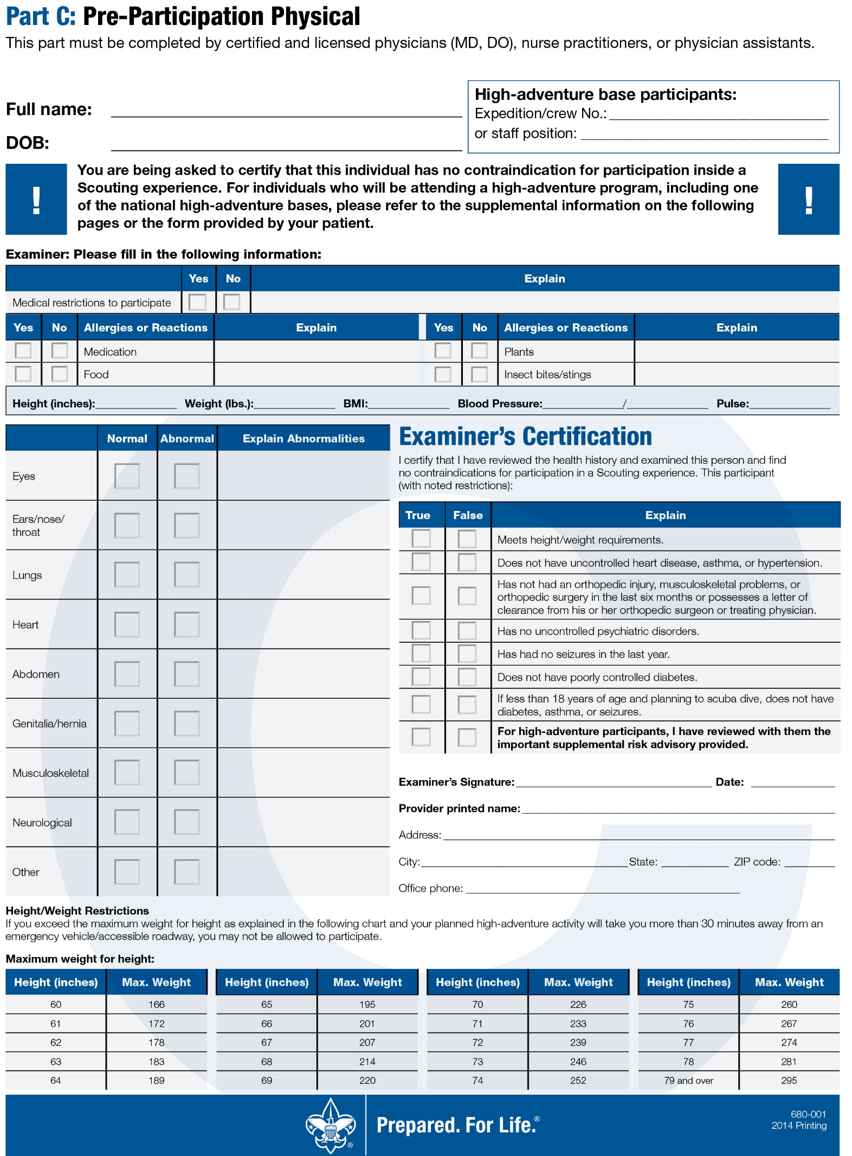
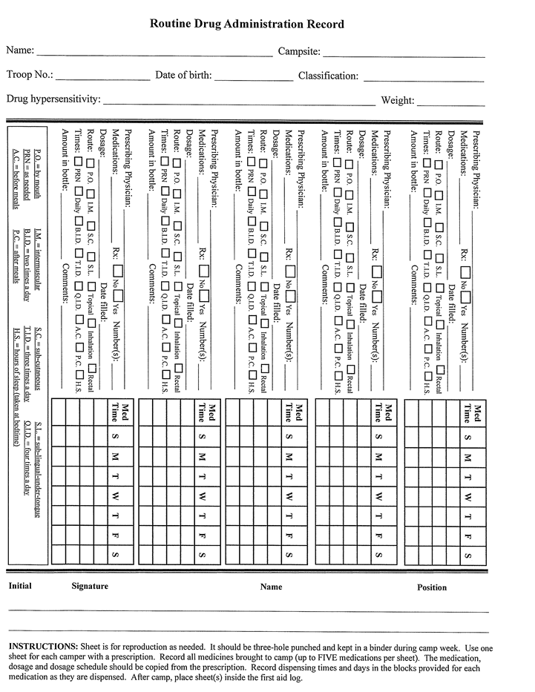

Tentaroo is our online merit badge registration software. To access the site use the following URL: https://www.tentaroo.com/greenmtn/
Once you get to the main page, you will login by using the email address of the primary point of contact and with your password being your troop and number as follows: troop123.
Once you log in, you will see six tabs at the top of the screen: Home, Profile, Your Roster, Event Registration, Cart, and Orders.
Under the Home Tab: You will see that you are registered for "Boy Scout Resident Camp," and which week you are registered for. Underneath the menu that displays your registered events, you will find an "Instructions" button that will help walk you through signing up for merit badges.
Under the Profile Tab: You will see your unit's information. This is where your contact information is stored so that I can contact you through the system. Please make sure everything is correct and update anything that needs to be changed. Make sure you click "Save Profile" if you make any changes! This is where you can change your password to Tentaroo once you have logged in.
Your Roster Tab: Here is where you will add your Scouts and Leaders that are coming to camp. All of your Scouts should already be in the system. Please double check this to make sure everything is correct. Leaders can be added in their own separate menu underneath your Scout roster.
Event Registration Tab: Here is where you can add Merit Badges! Click on "New Camper Registration." Select one of your Scouts from your troop. Once you have verified his Profile, click "Save Camper, Add to Cart." You will be immediately brought to the "Classes" tab. Simply drag and drop the merit badges from the right to the left. Make sure you review the key: there are symbols for estimated fees, extra information, age minimums, etc. If you hover your mouse over the blue question mark for each badge, you will get some info AND THE PRE REQ INFORMATION for that merit badge session!
Once you have selected all of the merit badges, click "Save Camper, Add Changes to Cart."
Once you have added all of your Scouts and their merit badges, MAKE SURE YOU CHECK OUT UNDER THE CART TAB! Otherwise your spots will not be saved in the classes!

If you need assistance please contact Janet by email Janet.Ruggles-Power@scouting.org
or call her at 802-244-5189.

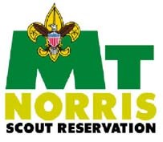
Scout Release Request

Instructions:

Scouts desiring to leave camp prior to the unit’s departure or not as a part of the unit must have a release signed by their parents and approved by the unit leader. Scouts will normally be permitted to leave only when accompanied by their parents. The form below must be used in handling all such departures.

In an emergency, it may not be possible for a parent or parents to sign the release. In this event, sufficient information must be recorded attesting to the telephone call or means of communication by which word arrived asking for the release of the Scouts. This information should document the person from whom the call was received, verify telephone confirmation of the parent asking for release of the Scout, and give detailed reasons for the requested release.

Request is made that ___________________________________________________________
Home Address ________________________________________________________________
District ______________________ Unit # _____________ Campsite ____________________

Be permitted to leave the unit for the following reason(s):
_____________________________________________________________________________
____________________________________________________________________________

The Scout is to leave on: Date ____________________ Time ___________________________

Accompanied by _______________________________________________________________

The Scout is to return on: Date ___________________ Time ___________________________

In signing this request for release, the BSA, the Green Mountain Council, the troop leaders and the Scout’s parents or guardians mutually acknowledge that there will be no refund of the camp fee; and that the BSA or its representatives shall not be liable for any loss or injury to the Scout’s person or property.

The request is made by (parents’ or guardians’ signature required except as noted for emergency departure requests)

Parent or guardian signature(s) ___________________________________________________
Address _____________________________________________________________________
Telephone # (H) ______________________ Request made (date & time) ________________
(W) _____________________
Unit Leader’s signature of approval________________________________________________

On-Site Release
Before leaving camp, Scout must check-out with their unit Leader and the Camp Headquarters.
Approvals
Signed: ____________________________ Unit Leader, Unit # ________________ Date _____________________

Signed: ____________________________ Camp Headquarters, Date _________________
Keep the original for use at time of release. Give parents a photocopy.
Mt. Norris Scout Reservation Alumni Association, Inc.

113 Center Road, Essex Junction, VT 05452

mtnorrisalumni@gmail.com

http://mtnorrisalumni.weebly.com

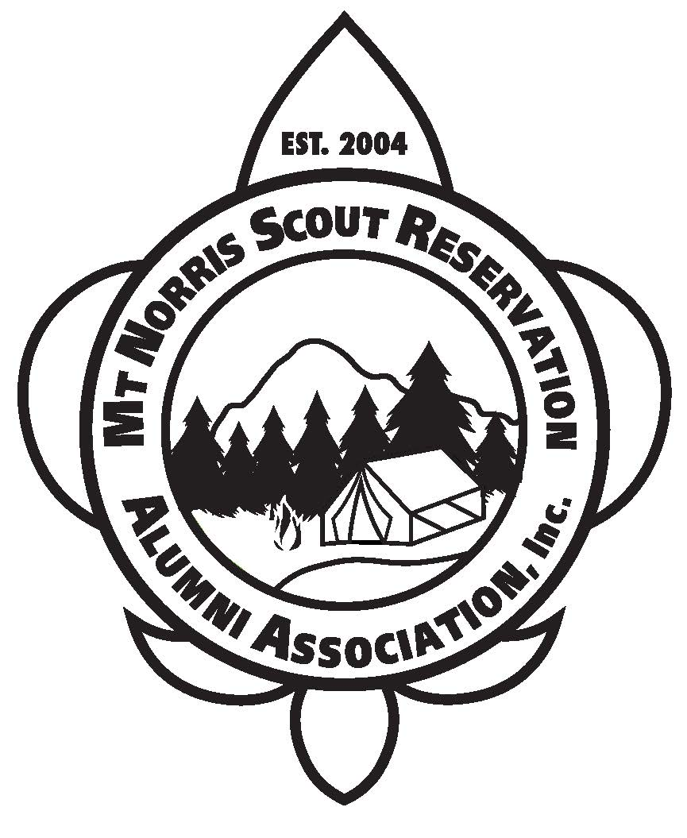
The Mt Norris Scout Reservation Alumni Association (MNSRAA) was founded in 2004 by members of the original Thumb Bangers. It was established as a 501(c)3 non-profit corporation in 2005. Its statement of purpose; “the corporation is established as a non-profit, volunteer organization, whose main objective is the support and enhancement of program, equipment, infrastructure, and facilities located at the Mt. Norris Scout Reservation, Town of Eden, Vermont.”

Membership is open to; “any person who supports the purpose of the corporation.”

Its mission statement; “to support the Green Mountain Council in developing and sustaining Mt Norris Scout Reservation as a premier, four season camp to the benefit of all Scouts and adult leaders.”

Committing to this larger role is still under consideration by the membership and the Board of Directors. Regardless of how little or how much you want to contribute to the legacy of Mt. Norris Scout Reservation, becoming a member of the alumni association is a good place to start.

Over the last twelve years we have had 247 members join. Our pre-camp and post-camp work weekends have made significant contributions to improving, repairing and rebuilding camp facilities. Dues and donations exceeding $65,000 have been invested in camp facilities, programs and equipment.

Please consider joining. Membership application form is on the next page.

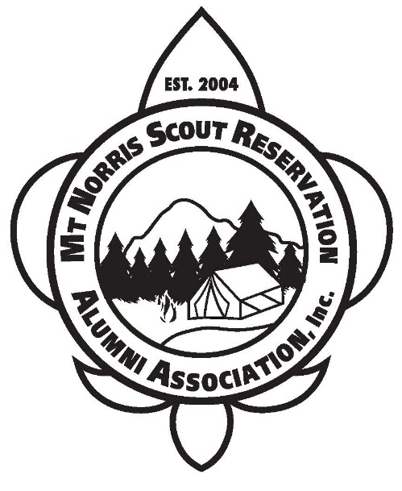 | Mt. Norris Scout Reservation  Alumni Association, Inc.  113 Center Road, Essex Junction, VT 05452  mtnorrisalumni@gmail.com  http://mtnorrisalumni.weebly.com  Bylaws, Article V, Section 5.1 Members: Any person who supports the purpose of the [alumni association] may become a member and shall be entitled to all benefits of membership, subject to responsibilities of membership, as established by the Board of Directors.
Membership Application
Applicant Information
Full Name: |  |  |  | Date:
 | Last | First | M.I.

Address:
 | Street Address | Apartment/Unit #

 | City | State | ZIP Code

Phone: |  | Email

- I would like to become a member. Enclosed please find my annual dues for 20________: $___25.00____
- Enclosed is an additional unrestricted donation: $____________
- Enclosed is an additional restricted donation for _______________________________: $____________

Total Enclosed: $

Make checks payable to MNSRAA. All donations are tax deductible.
Less than $5 of your dues goes to administrative and promotional expenses.
One hundred percent of all donations go to fund camp improvement and maintenance projects.
Your involvement and volunteer labor is of great value as well.

Scouting History (optional)

___Cub Scout ___Webelos ___Boy Scout ___Explorer ___Venture ___Adult Leader

Troop affiliation (if applicable):________________________________________________________

Thank You for Your Support

Green Mountain Council
P.O. Box 557
Waterbury, VT 05676-0557
National Youth Leadership Training

National Youth Leader Training (N.Y.L.T.) is an exciting, action-packed program designed to provide all youth members of the Scouting Community with leadership skills and experience they can use in their home unit and in other situations demanding leadership of self and others.
The Youth Training Continuum
Youth leadership training is a three-phase training experience, and a common thread will connect all three phases. The first phase begins in the unit with the senior youth and adult leader conducting either the Troop Leadership Training (TLT/ILST) or the Venturing Leadership Skills Course (VLSC/ILSC). Phase two is NYLT conducted by the experienced youth and adult staff of the Green Mountain Council. The third phase is the weeklong National Advanced Youth Leadership Experience (NAYLE) at the Philmont Scout Ranch.
Course Overview
The NYLT course centers around the concepts of what a leader must BE, what he must KNOW, and what he must DO. The key elements are then taught with a clear focus on HOW TO. The skills come alive during the week as the patrol goes on a Quest for the Meaning of Leadership.
NYLT is a six-day co-educational course. Content is delivered in a group and team outdoor setting with an emphasis on immediate application of learning in a fun environment. Interconnecting concepts and work processes are introduced early, built upon, and aided by the use of mnemonics (memory aids) which allows participants to understand and employ the leadership skills much faster.
To Attend You Must:

- Be 13 years old by the start of the course (14 years old is highly recommended)
- Be a 1st Class Scout (Boy Scouts)
- Have completed TLT/ILST or VLSC/ILSC
- Be recommended by your Unit Leader
- Hold a leadership position in your Unit
- Be prepared mentally, emotionally, and physically to handle a week of NYLT
- Be in attendance for the entire course!
- Pay all fees by June 2, 2017

NYLT is Not: A typical summer camp! A time to work on Merit Badges!

NYLT is: A self-improvement week that will benefit you for years to come!
A uniformed training course. Leadership, Fun, Challenge & Adventure! GMC’s “Centerpiece” of Youth Training.

ACCEPTANCE OF INVITATION:

I accept the invitation to attend the GMC’s NYLT Course, to be held June 28-July 3, 2017 at Camp Sunrise. I have or will have completed TLT/ILST or VLSC/ILSC in my unit before I attend NYLT. A $330 course fee is due by June 1st. (Early bird discount of $305 if paid by May 18, 2016). A $50 non-refundable deposit is enclosed. Please print legibly.
Name: ________________________________________
I like to be called: ________________________________
Address: ______________________________________
______________________________________________
______________________________________________
e-mail: ________________________________________
Home Phone: (_______) _______ - _____________
Date of birth: ______/______/______
Council: _______________________________________
Unit number: ___________________
Leadership Position: _____________________________
TLT or VLSC Completed on: ______/______/______
Adult T-Shirt Size: S M L XL XXL XXXL
Unit Leader Approval:
______________________________________________
(signature)
______________________________________________
(please print name)
______________________________________________
(e-mail address)
Please return to:
Green Mountain Council-BSA
PO Box 557
Waterbury, VT 05676-0557
Tel. 1-802-244-5189

Course Director: Lucy Neel
Tel. 802-779-7015
Beehive1_2000@yahoo.com
